Chapter 3
RESEARCH METHODOLOGY
This chapter discusses the methodology used to develop IronGrind: A Web-Based Fitness Gym Membership and Operations Management System for Iron Grind Fitness Gym in Purok Mangga, Sulangon, Dapitan City, Zamboanga del Norte. It describes the development process, system requirements, design, data organization, and evaluation procedures. The system is intended to organize membership applications and records, membership periods and renewals, staff-recorded attendance, products, sales, and reports. Its development is organized using Agile, with work planned and delivered incrementally. Proposed evaluation activities are distinguished from results that have not yet been collected.

System Development Methodology

Figure 1. Agile
Agile is an iterative system-development approach in which requirements guide the work, features are built in manageable increments, and the results of testing and review guide subsequent work. As shown in Figure 1, the process begins by planning IronGrind's workflows and priorities and designing the related pages, forms, data relationships, and access permissions. The team then develops a selected group of features and tests them against their requirements. Deployment in the cycle means preparing and checking an increment in its intended environment; review considers the test findings and any feedback actually collected. Those findings return to planning and help determine what to refine or build next. This cycle applies to the system's membership applications and renewals, attendance, inventory, sales, and reports. The final Launch stage represents release of the approved system for operational use after the required increments have been verified. Figure 1 describes this project's workflow; it does not claim use of a specific Agile framework or a fixed iteration length. Evaluation results are reported only after the planned evaluation activities have been completed.

Requirements Planning
Requirements planning identifies separate workflows for applicants, members, administrators, and authorized staff. Requirements cover online applications subject to authorized staff or administrator review, direct counter registration and membership changes, QR attendance, product inventory, transaction recording, reporting, staff accounts, phone pairing, and activity logs. Acceptance criteria include role permissions, required inputs, stock and membership updates, and rejection of unauthorized operations. These criteria guide each development increment.

User Design
Using the prioritized requirements, the team designs or refines the corresponding user workflows, page layouts, forms, reports, data relationships, and role permissions. For example, the design distinguishes pending applications from approved member records, keeps attendance as a separate operational record, and stores sales with their itemized lines. The architecture, use-case, and data-flow figures in this chapter summarize how these parts fit together. These designs are then represented in prototypes so that the intended workflows can be reviewed before or during construction.

Prototype
The prototype represents the designed workflows through browser-based pages. Applicants submit registration details, while members view their membership, attendance, QR code, profile, catalog, and renewal requests. Administrators view member profiles without editing personal details, review online requests, perform membership operations, and handle inventory, sales, staff access, phone pairing, activity logs, and reports. Staff use a separate portal for attendance, walk-in registration, direct membership renewals and active-member plan changes, product sales, their own product-sale records, and online registration and renewal request approval. The system records in-person transactions without providing receipts to customers. Supabase Auth, database policies, functions, and authorized Edge Functions support the implemented operations.

Construction
The team constructs the selected increment using the HTML, CSS, and JavaScript client and Supabase authentication and PostgreSQL services. Database policies and functions support authorization and operational transactions. The completed increment is tested against the acceptance criteria established during planning. If a test identifies an issue, the team corrects it and checks it again; unresolved or newly discovered needs are recorded for prioritization. Once the increment passes the required checks, it can be prepared in the intended environment and reviewed. Test findings and any feedback actually collected inform the next planning cycle, connecting construction to continued refinement.

Implementation
Implementation prepares the verified increments for operational use. The team configures the website and Supabase project for the intended environment, applies the approved access policies, and prepares administrator access. Deployment refers to this environment preparation and release check; Launch is the point at which the approved system is made available for the gym's intended workflows. Staff orientation supports the transition to use. These activities follow testing and review, and their outcomes are reported only after they have actually been completed.

Requirement Specifications
This section outlines all the requirements needed for the IronGrind System. These requirements serve as the foundation for the system's design and validation. The requirements are divided into several categories: functional requirements, input requirements, output requirements, software requirements, and hardware requirements. Each category plays an important role in making sure the system is complete, efficient, and meets the needs of its users.

Functionality Requirements
Functional requirements distinguish applicants and members from administrators and authorized staff. Authorized staff and administrators can approve or reject online registration and renewal requests. Staff have assigned counter and attendance operations, while stock maintenance, staff account controls, phone pairing administration, activity-log review, and reports remain administrator functions.
Table 1. Functional Requirements
This section describes the main operations such as managing memberships, processing applications, recording attendance via QR, managing inventory, and generating reports. These functions ensure accurate record-keeping, efficient administration, and secure system operation.
Functional Requirements | Description
User Login | Authenticate administrators, staff, and members and enforce role-based access.
Membership Applications | Applicants submit registration requests; authorized staff and administrators review and approve or reject them.
User Management | Administrators view member profiles without editing personal details and control staff-account access. Members alone update their own permitted personal profile details. Staff register walk-ins and process direct renewals or active-plan changes using limited lookup details; they cannot view or edit member profiles.
Renewals | Members request renewal; authorized staff and administrators review online requests. Direct staff counter renewals are covered under User Management.
QR Attendance | Authorized operators record QR check-in/out and read permitted visits; members read only their own history. Administrators manage phone pairing and its settings.
Products & Inventory | Administrators maintain products, prices, units, stock and active state. Members browse active products; staff read the sales catalog without inventory-maintenance access.
Sales | Authorized operators record in-person product sales and stock deductions. Staff review only their own product sales. Transactions are recorded without providing receipts.
Generate Reports | Administrators generate membership, attendance, inventory, sales and renewal reports with supported preview and export options.
Activity Logs | Administrators review recorded actions, including staff-account changes and phone-pairing events. This read-only function does not perform the logged operations.
Table 2. Input Requirements
Input requirements are the essential data and information that the IronGrind system needs to function properly. By ensuring that all required inputs are complete and accurate, the system can deliver reliable outputs and support effective decision-making.
Input Requirements | Description
User Login | Credentials and session details.
Membership Applications | Registration and health details from applicants; administrator review decisions.
User Management | Administrator profile-view queries, membership operations and staff-account controls; member own-profile queries or permitted edits; staff walk-in details, limited searches, direct renewal or active-plan selections.
Renewals | Member renewal request and administrator review decision.
QR Attendance | Operator member QR and attendance query; member own-history query; administrator pairing setup, settings or removal request.
Products & Inventory | Administrator product/stock inputs; member active-catalog query; staff sales-catalog query.
Sales | Customer name, product, quantity, unit and payment details; permitted transaction query.
Generate Reports | Administrator report type and reporting period.
Activity Logs | Administrator filters for date, account name, action and area, plus pagination requests.
Table 3. Output Requirements
These are the main results or information that the system produces after processing the input data:
Output Requirements | Description
User Login | Authentication result and permitted dashboard.
Membership Applications | Own application status and administrator pending/reviewed application records.
User Management | Role-permitted user records and confirmations. Member: own profile. Staff: limited counter lookup and operation result only. Administrator: read-only member profiles, membership-operation results and staff-account states.
Renewals | Request status and updated membership dates following approval.
QR Attendance | Attendance confirmation/history appropriate to the role; administrator pairing states and settings.
Products & Inventory | Active/permitted catalog; administrator stock levels, product state and alerts.
Sales | Saved transaction and stock deduction; staff own product-sale records. No issued receipt.
Generate Reports | Report preview, print layout, PDF output or combined ZIP export.
Activity Logs | Filtered recorded activity showing time, actor, action, area and changed-field information.
Table 4. Software Requirements
The following software components are essential for both the development and deployment of the IronGrind System. These tools ensure that the system operates smoothly, meets all technical requirements, and delivers the necessary functionality.
Development | Description
Visual Studio Code | For coding and development.
HTML, CSS, JavaScript | For frontend design and user interface.
Supabase /PostgreSQL | For backend services, authentication, and PostgreSQL database management.
PgAdmin | Used to inspect and manage the Postgre SQL database and execute queries during development.
Git / GitHub | For version control and code repository.
Google Chrome or Microsoft Edge | For accessing and testing the system interface.
Table 5. Hardware Requirements
The hardware requirements describe practical development and operating equipment rather than benchmarked minimum performance. A browser-capable computer and stable internet connection support the main system; a supported camera-enabled phone or computer supports QR attendance. Printing is optional for operational reports. A dedicated POS terminal or receipt printer is not required.
Component | Minimum Specification | Recommended Specification | Description
Storage Drive | HDD 500 GB | SSD 500 GB or higher | The system is web-based, but an SSD improves local development and browsing speed.
Memory (RAM) | 8GB | 16GB or higher | Works with 8 GB RAM, but 16 GB+ is faster and more stable, especially for multitasking.
Processor (CPU) | Intel Core i3 | Intel Core i5 or higher | Both processors can run the system, but i5 delivers faster processing.
Laptop | Basic Laptop (Intel Core i3, 8GB RAM) | Mid-range Laptop (Intel Core i5, 16GB RAM) | Used by the gym owner/admin for managing the dashboard, applications, inventory, and generating reports.
Front-desk Device | Browser-capable computer | Computer with supported camera | Used for membership, attendance, and transaction recording; dedicated POS hardware is not required.
Printer | Optional | Available office printer | Optional printing of operational reports; receipt printing is not a requirement.
Operating System | Windows 10 (64-bit) | Windows 11 (64-bit) | Both operating systems are compatible with modern web browsers and POS software.
Camera/Scanner | Supported camera-enabled device | Clear-focus phone camera or webcam | Camera permission and a secure browser context support QR scanning. Paired phone use remains subject to operator authorization.
Internet Connection | 5 Mbps | 20 Mbps or higher | Since the system uses Supabase (cloud), a stable internet connection is required for real-time data syncing.

Data Process Modeling
The Data Process Modelling illustrates how data flows within the IronGrind System. It describes how information is gathered, processed, stored, and retrieved by the system. This model helps visualize the relationship between the users, the system processes, and the data stored in the system's Supabase PostgreSQL database.

Diagrams
In this study, diagrams serve as visual representations that illustrate how data and processes flow within the Iron Grind Fitness Gym Membership & Operations Management System. Each diagram shows how information is entered, processed, stored, and produced as system output. The visual format clarifies the structure, functions, and interactions among the users, system processes, and database. By presenting the system in a clear and organized graphical layout, each diagram simplifies complex workflows and supports easier analysis and understanding. Every illustration also provides an overview of how all modules operate together to achieve efficient gym management.
In addition, each diagram contributes to identifying potential areas for improvement by highlighting connections, dependencies, and overall workflow behavior. The graphical representation helps developers and stakeholders visualize how every process supports the system's intended functions. Accurate documentation is also supported, ensuring proper interpretation during development, refinement, and evaluation. Overall, each diagram plays crucial role in communicating the system's design, logic, and expected performance in a structured and easy-to-interpret format.
Figure 2 is the context diagram. It contains one process, numbered 0, representing IronGrind and three external actor groups: Member / Applicant, Administrator, and Authorized Staff. Databases, authentication services, and phone-pairing storage remain internal to the system boundary.
- The Member/Applicant provides inputs such as sign-in credentials, registration details, membership applications, renewal requests, and profile updates. In return, the system provides outputs including authentication results, application statuses, membership details, attendance history, the active product catalog, and account information.
- The Administrator provides application review decisions, membership and inventory updates, sales entries, staff account controls, phone-pairing administration, and report or activity-log queries.
The system returns the corresponding records, status confirmations, account information, activity logs, and reports. Authorized staff provide attendance scans, walk-in registration details, direct renewal and plan-change inputs, online request decisions, and product sales entries; they receive only the confirmations and records permitted for their role.

Context Diagram
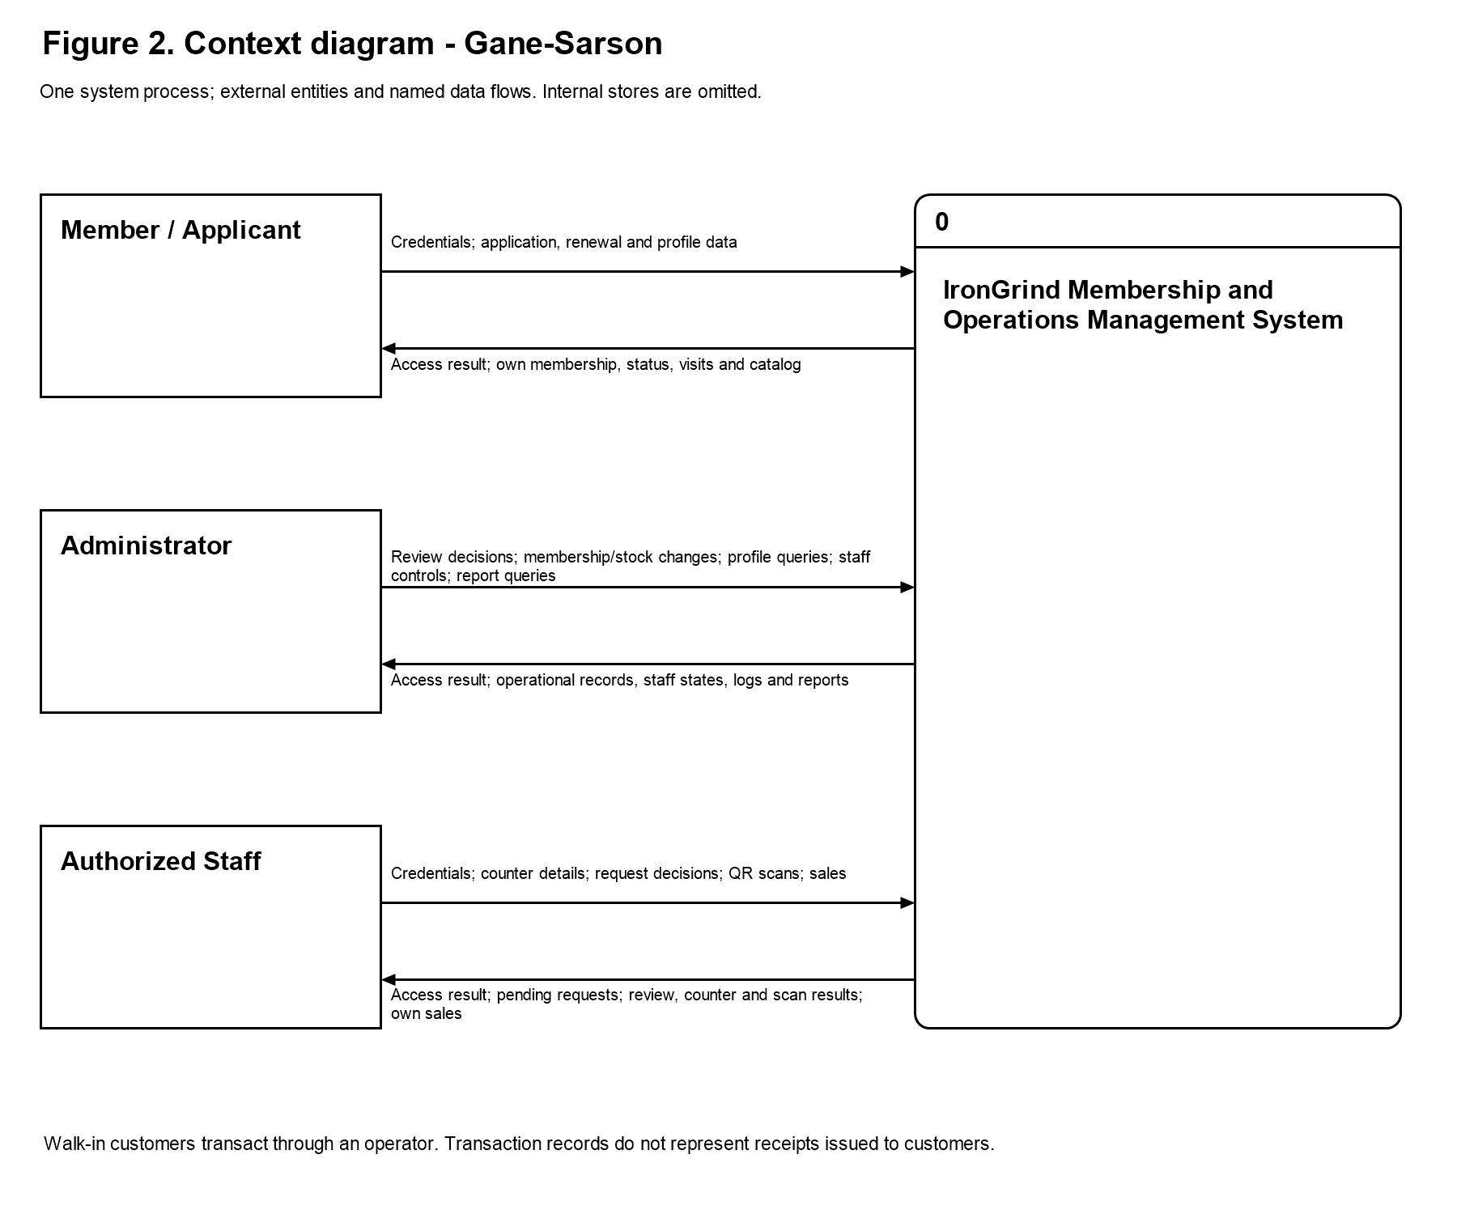
Figure 2. Context - Gane-Sarson
Figure 2 presents the boundary of IronGrind using Gane-Sarson notation. The numbered rounded process represents the entire membership and operations system, while the rectangular external entities identify the Member / Applicant, Administrator, and Authorized Staff. Named arrows show the information submitted to the system and the information returned to each actor. The diagram is a context view rather than an internal design: it intentionally does not display individual database tables, authentication components, or detailed subprocesses. Those internal responsibilities are explained in the Level 1 DFD.
The Member / Applicant exchanges information relating to registration, account access, membership, and personal self-service. An applicant submits registration details and receives the status of the application. A registered member can retrieve their own membership information, QR code, attendance history, and active product catalog, submit a renewal request, and update their own permitted personal details. These flows describe access to the memberâ€™s own information; they do not give a member access to another personâ€™s records or to administrator functions.
The Administrator exchanges review decisions, membership-operation inputs, inventory and sales information, staff-account controls, phone-pairing requests, report queries, and activity-log filters. The system returns the records and confirmations needed for those operations. Administrator access to a memberâ€™s personal profile is read-only: viewing the information does not permit editing the memberâ€™s personal details. Membership approval, renewal, and plan changes are separate operational actions and should not be interpreted as personal-profile editing.
Authorized Staff exchange only the information required by their assigned attendance and counter tasks. These tasks include QR attendance, walk-in registration, direct membership renewal, active-member plan changes, product-sale recording, and review of their own product sales. A counter search returns limited details needed to select the correct member; it is not a member-profile viewing function. Staff can approve or reject online applications and renewal requests using limited request information. They cannot view or edit member profiles, maintain inventory, manage staff accounts or phone pairings, or access administrator reports and activity logs. Walk-in customers transact through an operator rather than acting as direct system users, and transaction confirmations do not represent receipts issued to customers.
The Member / Applicant submits credentials, registration details, renewal requests, and profile changes and receives their own application status, membership information, attendance history, QR code, and active catalog. Administrator and staff inputs differ according to their assigned permissions. Transaction confirmations refer to saved system records; they do not represent receipts issued to customers.

Data Flow Diagram
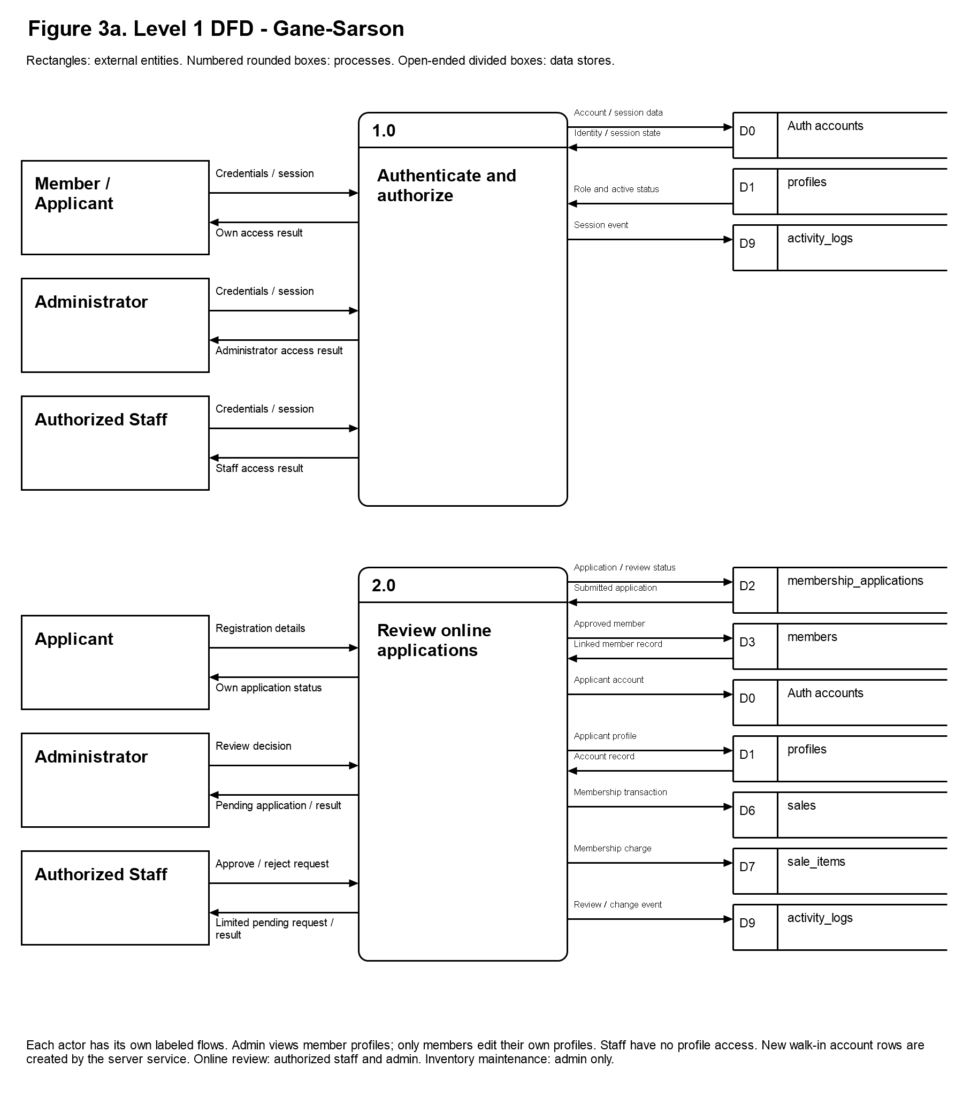
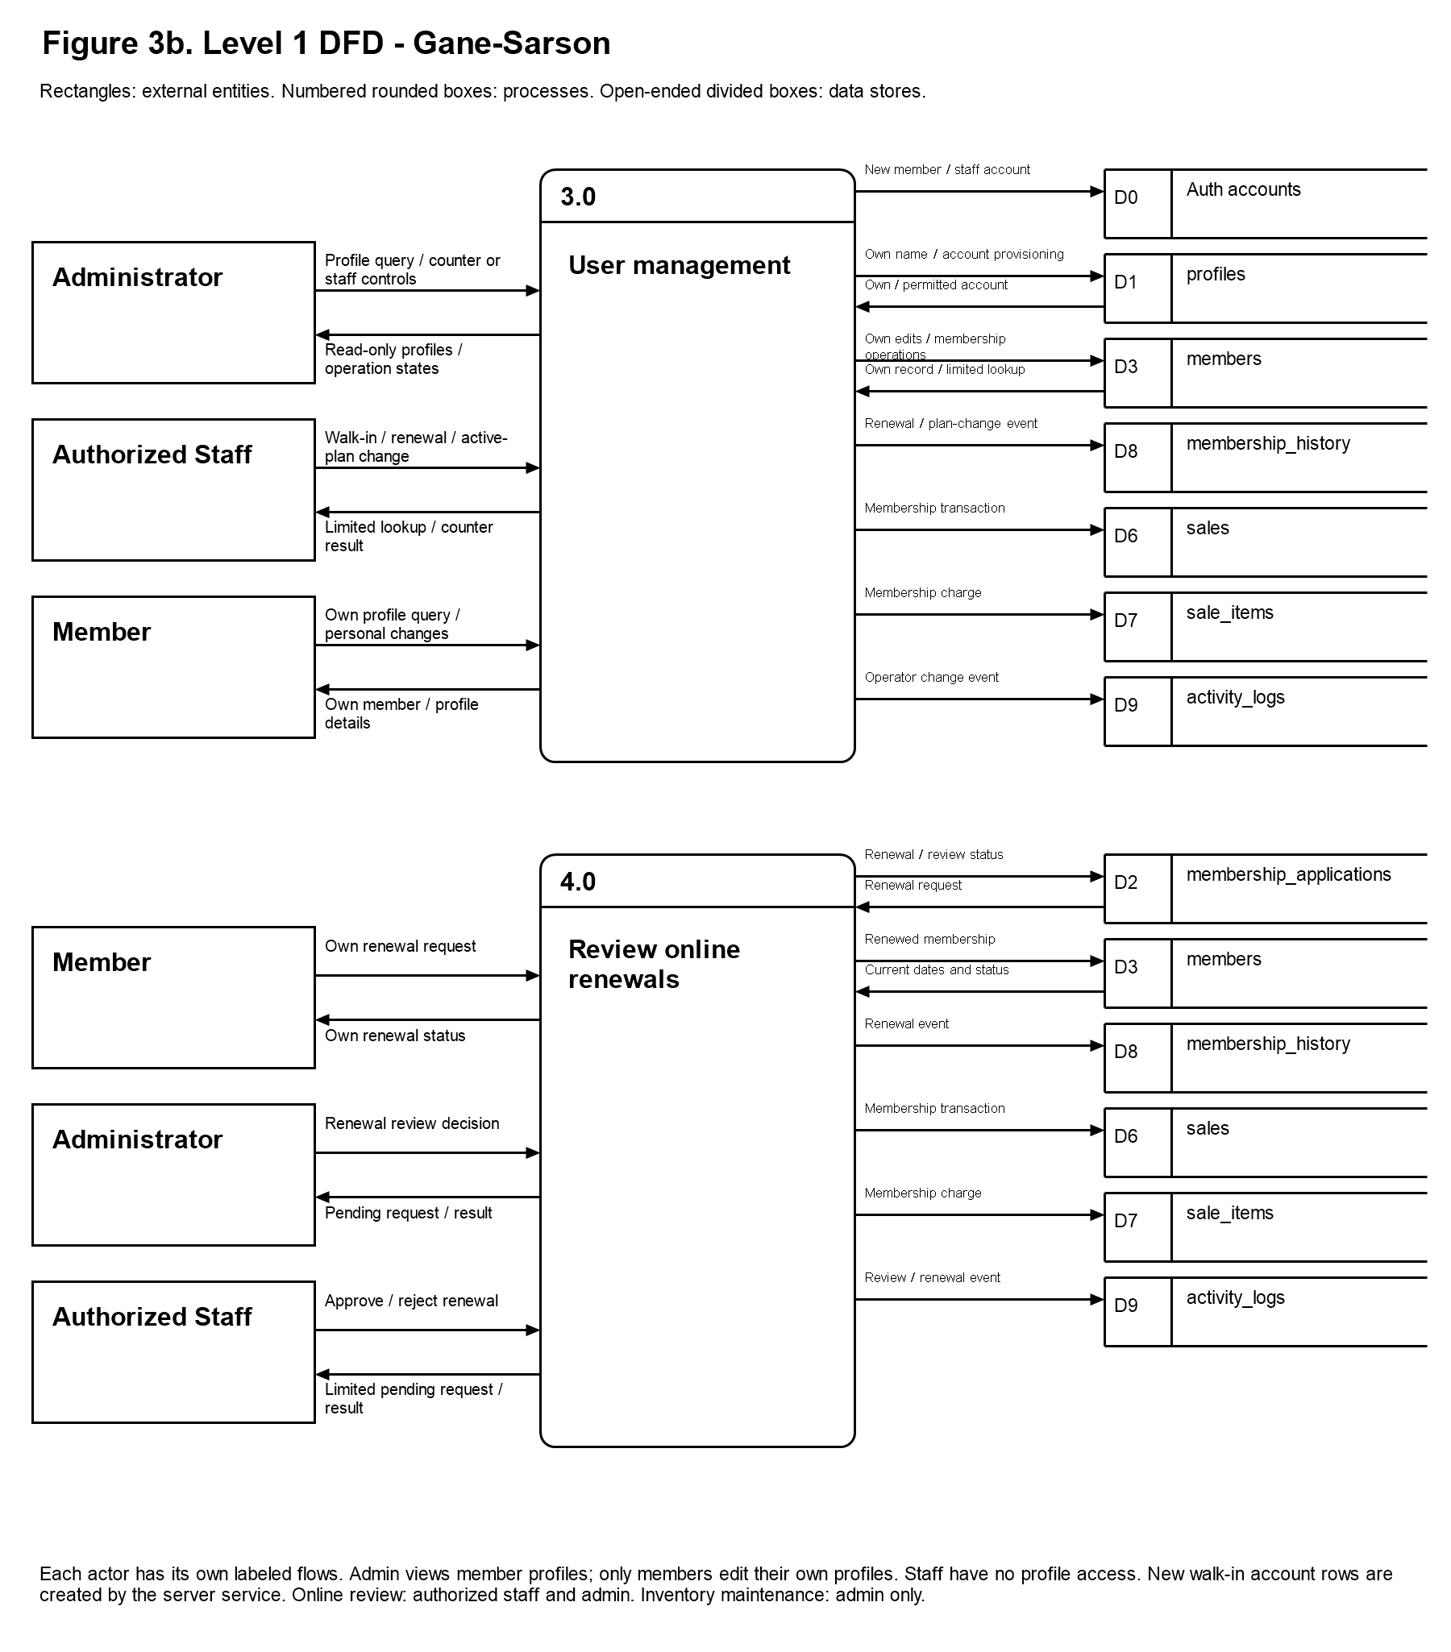
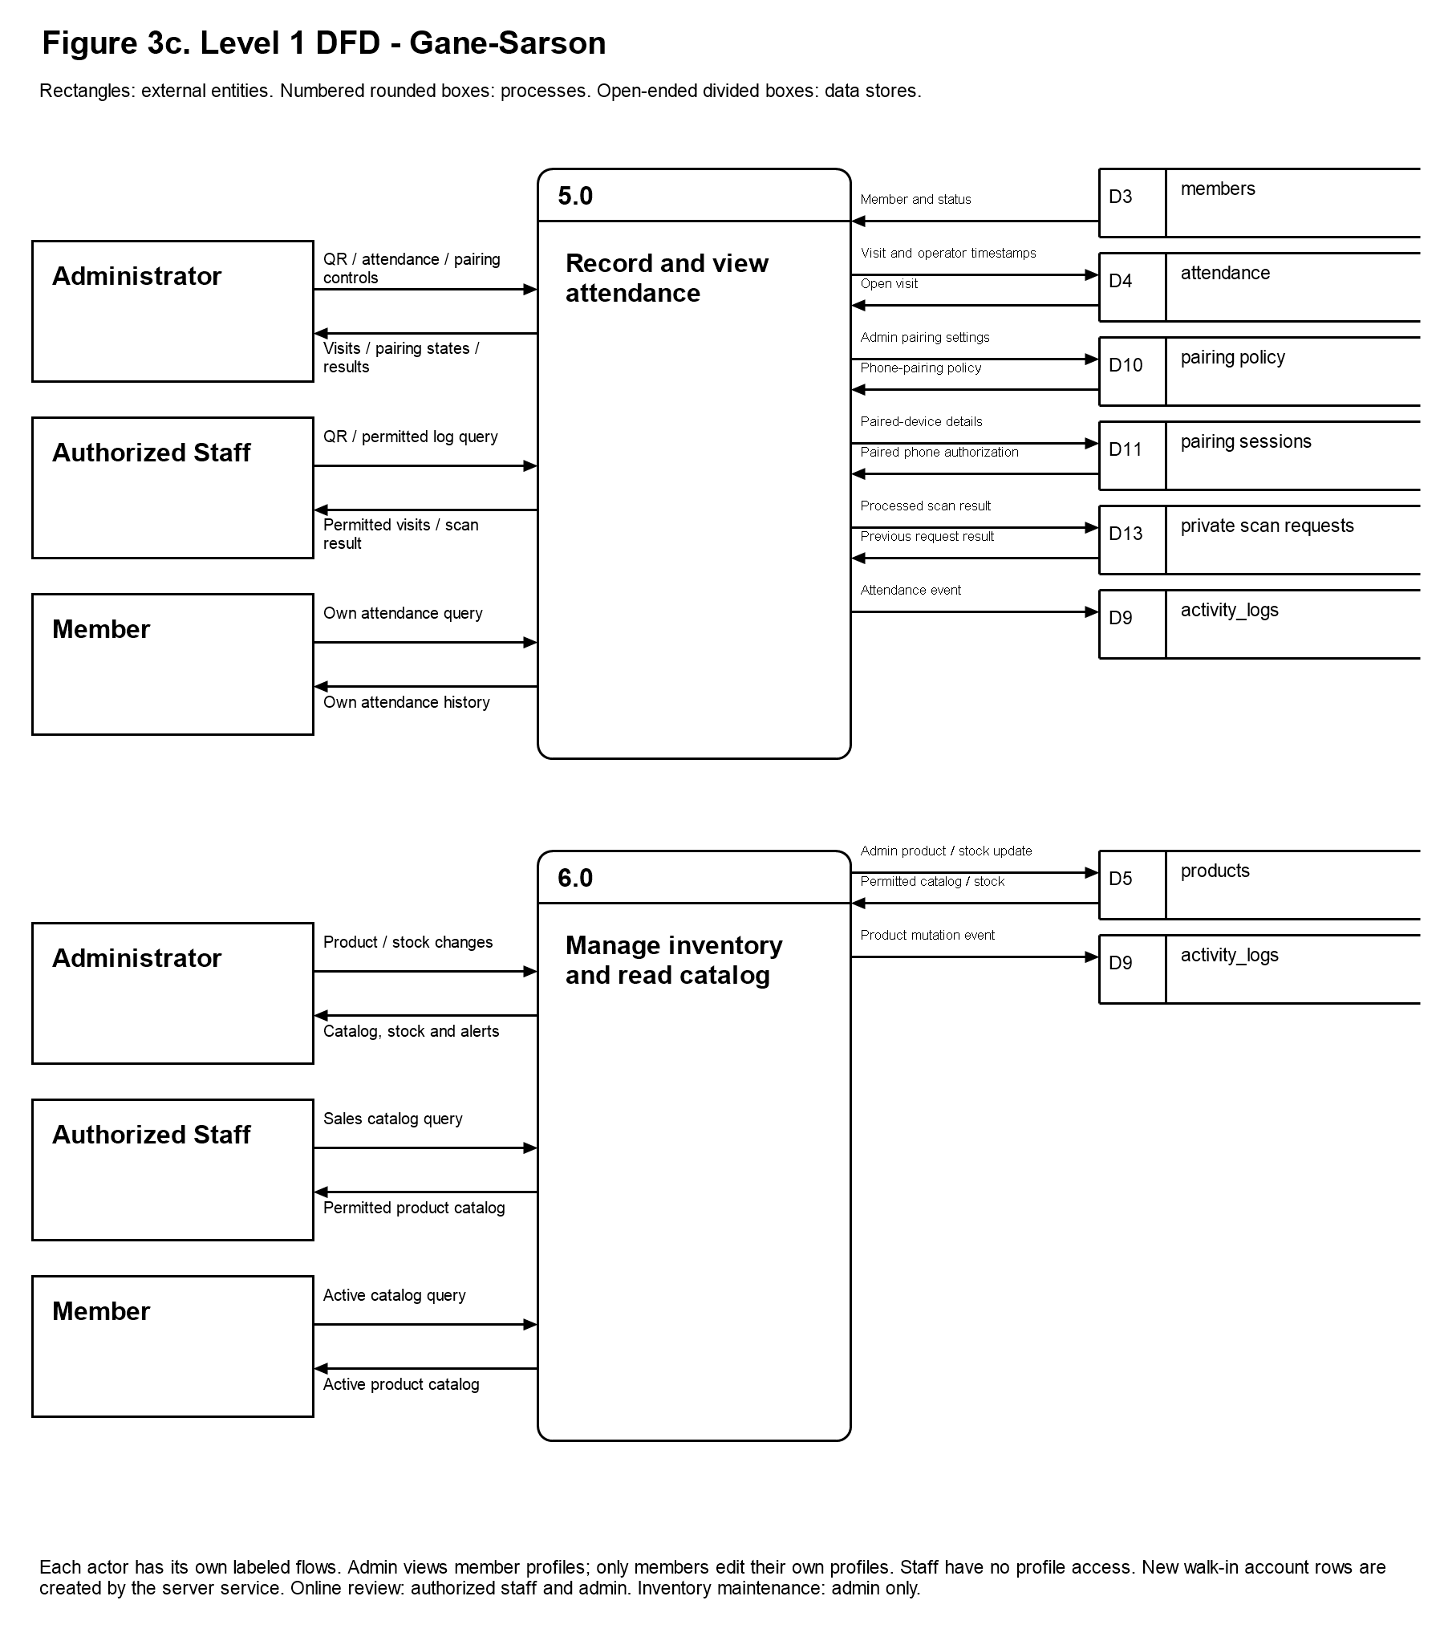
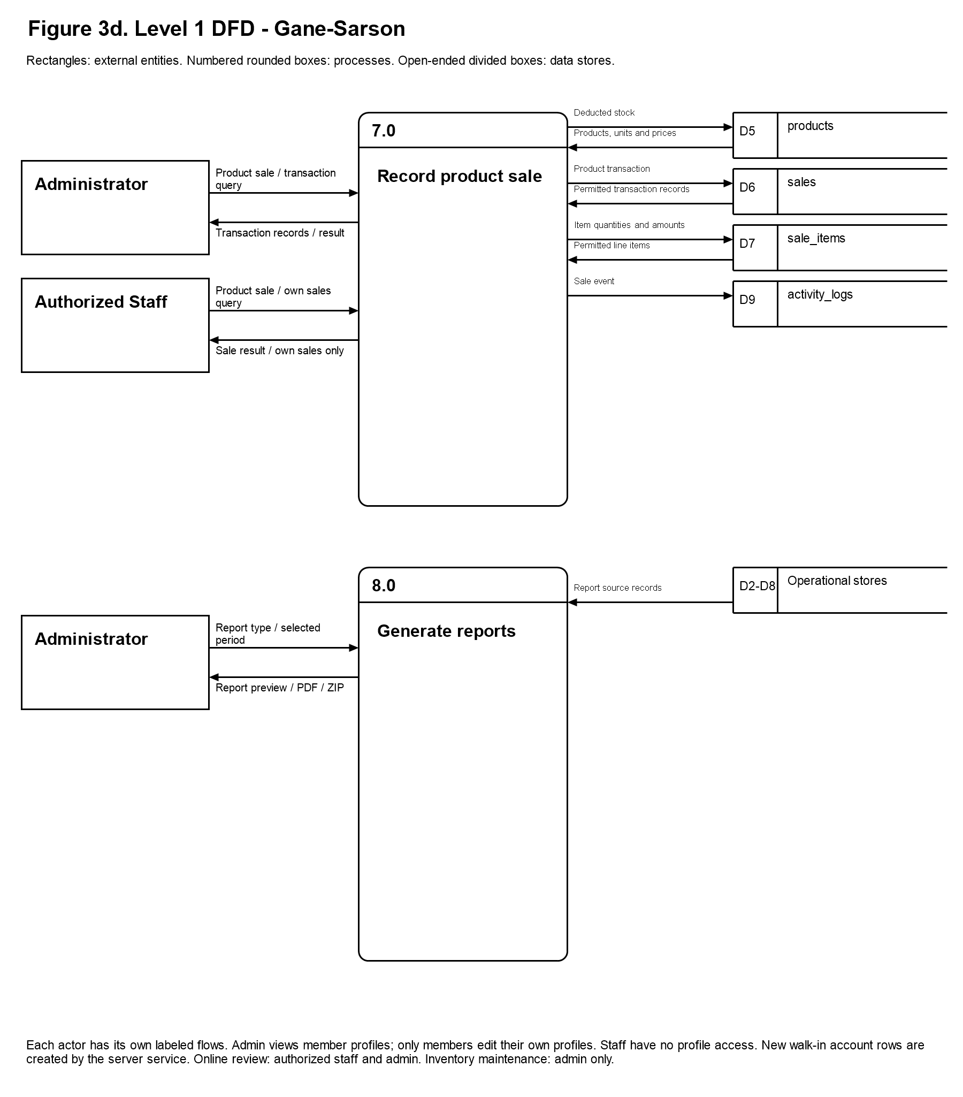
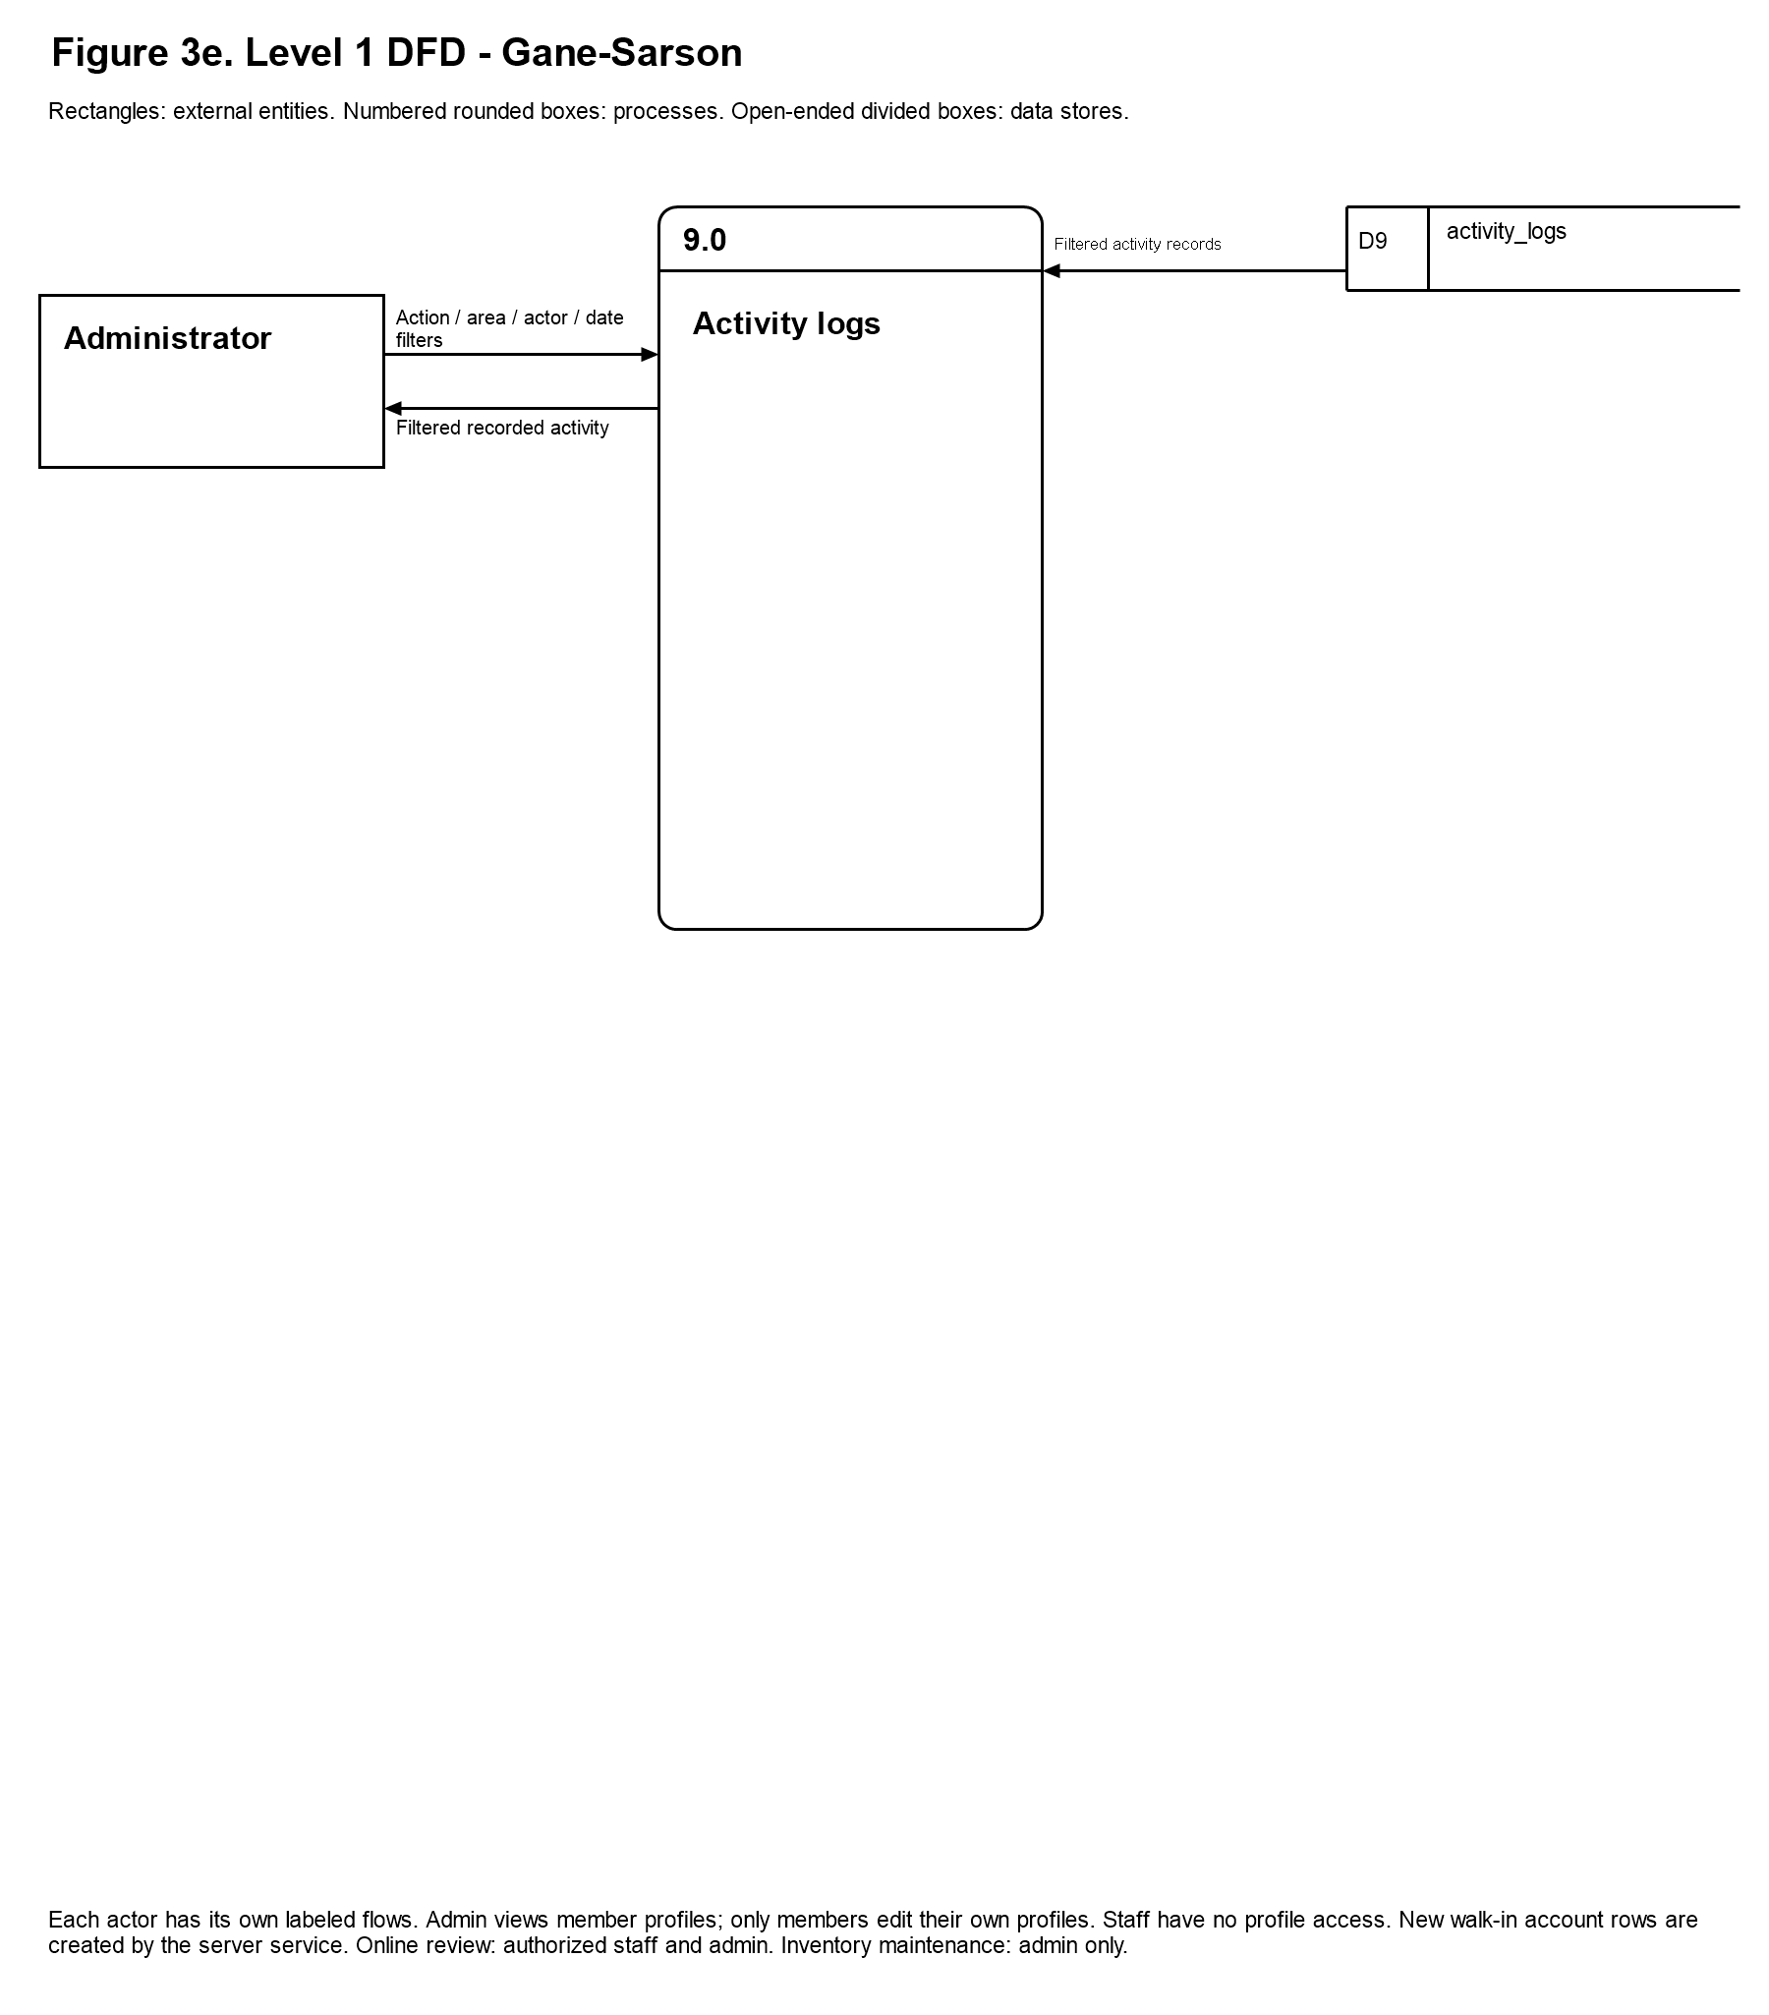
Figure 3a-e. Level 1 Data Flow - Gane-Sarson
Figure 3a-e expands the context process into nine functional processes using Gane-Sarson notation. The five panels are continuations of one Level 1 model, not five separate systems. Each rounded process box has a distinct number and a name identifying the work it performs. Rectangles identify external actors, while the open-ended data-store symbols separate the store identifier from its name. Every arrow is directional and is labeled with the information exchanged. Reading the actor, process, and store together explains who initiates an operation, what the system does with the input, and where the resulting information is retrieved or recorded.
Store identifiers remain consistent across all panels. D0 represents managed authentication accounts, D1 profiles, D2 membership applications, D3 members, D4 attendance, D5 products, D6 sales, D7 sale items, D8 membership history, and D9 activity logs. D10 represents phone-pairing policy, D11 pairing sessions, and D13 private attendance scan requests. D12 is reserved for the retained scan-event table in the physical schema and is not shown as an active frontend feature. Repeated symbols refer to the same actor or store. The D2-D8 symbol in reporting groups the operational sources read for reports; it does not introduce an additional physical table.
The actor-specific arrows are essential to interpreting User Management and attendance correctly. An administratorâ€™s profile-view query returns a read-only member profile. A memberâ€™s personal-change request affects only their own permitted personal details. Staff arrows identify counter and attendance operations and do not include a profile query or personal-detail edit. Internal writes caused by registration, renewal, or server-side account provisioning describe the effects of an authorized operation; they are not a grant of general editing access to the underlying table. Authentication, role checks, database policies, and authorized functions support these boundaries even when different operations use the same data store.
Processes 8.0 and 9.0 have distinct outputs. Generate Reports reads operational records to produce the selected report and its supported preview or export. Activity Logs reads previously recorded events and returns the administratorâ€™s filtered results. Staff-account changes occur under User Management, and phone-pairing changes occur under QR Attendance administration. Their events may appear in the log, but the log viewer does not perform those changes. This separation prevents the model from treating monitoring an operation as permission to execute it.
- 1.0 Authenticate and Authorize
Supabase Auth verifies credentials and establishes the user session. The system reads the profile role and active-account state to route the account to the administrator, staff, or member interface. Authorization is enforced through database policies, role-checked functions, and Edge Functions, rather than relying on page visibility alone.
2.0 Review Online Applications. Applicants submit registration details and health declarations to membership_applications. Only administrators review online requests and approve or reject them. Approval creates or links the member record, updates the application status, and records the applicable membership payment through sales and sale_items. Direct walk-in registration follows process 3.0 instead of granting staff online-review permission.
3.0 User Management. Administrators can view member profiles but cannot edit their personal information. They perform authorized membership operations and create or activate/deactivate staff accounts through authorized services. Members can retrieve and update only their own permitted personal details. Staff have a separate labeled counter flow: walk-in registration, limited member lookup, direct renewal, and active-member plan change. Staff cannot view or edit existing member profiles. Account rows created by the registration service describe backend storage, not profile-editing permission granted to staff. Membership changes record applicable member, history, sales, and sale-item updates.
4.0 Review Online Renewals. Members submit renewal requests to membership_applications. Administrators approve or reject these requests. An approved renewal preserves unused time by extending an active membership from its current expiry date; an expired membership restarts on approval. Approval updates the member, history, application status, and membership transaction records. Direct counter renewals by an administrator or staff operator belong to process 3.0 and do not grant staff permission to review online requests.
5.0 Record and View Attendance. An authorized administrator or staff operator scans a member QR code with a supported computer or phone camera. The database validates the operator and member, checks for an open visit, and records check-in or check-out in attendance. recorded_by and checked_out_by identify the operators for each event. Private attendance_scan_requests records support duplicate-request protection. Paired phones additionally use administrator-managed pairing sessions and policy; pairing does not replace operator authentication. Members can read their own attendance history. Authorized staff and administrators read attendance within their permitted scope. Administrator-only phone-pairing creation, settings and removal belong to this attendance workflow. Staff and members do not receive those administration controls.
6.0 Manage Inventory and Catalog. Administrators maintain product details, prices, stock, product forms, and active or archived state. Powder supplements support weight units; drinkable supplements support volume units; capsules and tablets use pieces or boxes; other supplements and merchandise use items. Sale processing converts compatible quantities and deducts stock using the configured inventory units. Members browse active products, and staff obtain the permitted catalog needed for sales; these read operations do not grant inventory-maintenance permission.
7.0 Sales
Administrators and staff record in-person product purchases for members or walk-in customers. The sale operation validates quantities and product status, writes sales and sale_items, and deducts product stock. Membership charges are recorded through the membership operations in processes 2.0 to 4.0. The database retains the existing receipt_number field as an internal transaction identifier. The documented operating process does not provide customers with receipts.
8.0 Generate Reports
Administrators select a report type and period to retrieve the relevant operational records. Supported outputs include preview, print layout, individual PDFs, and combined ZIP export. This reporting process does not manage staff access, phone pairings, or activity-log filters.
9.0 Activity Logs. Administrators review database-recorded actions using date, account, action, and area filters and pagination. Logs include recorded staff-account changes and phone-pairing events. The interface reads activity_logs; it does not create staff accounts, alter pairing settings, or modify the recorded events. Those operations occur in User Management or QR Attendance and produce their own log entries.

Use Case Diagram
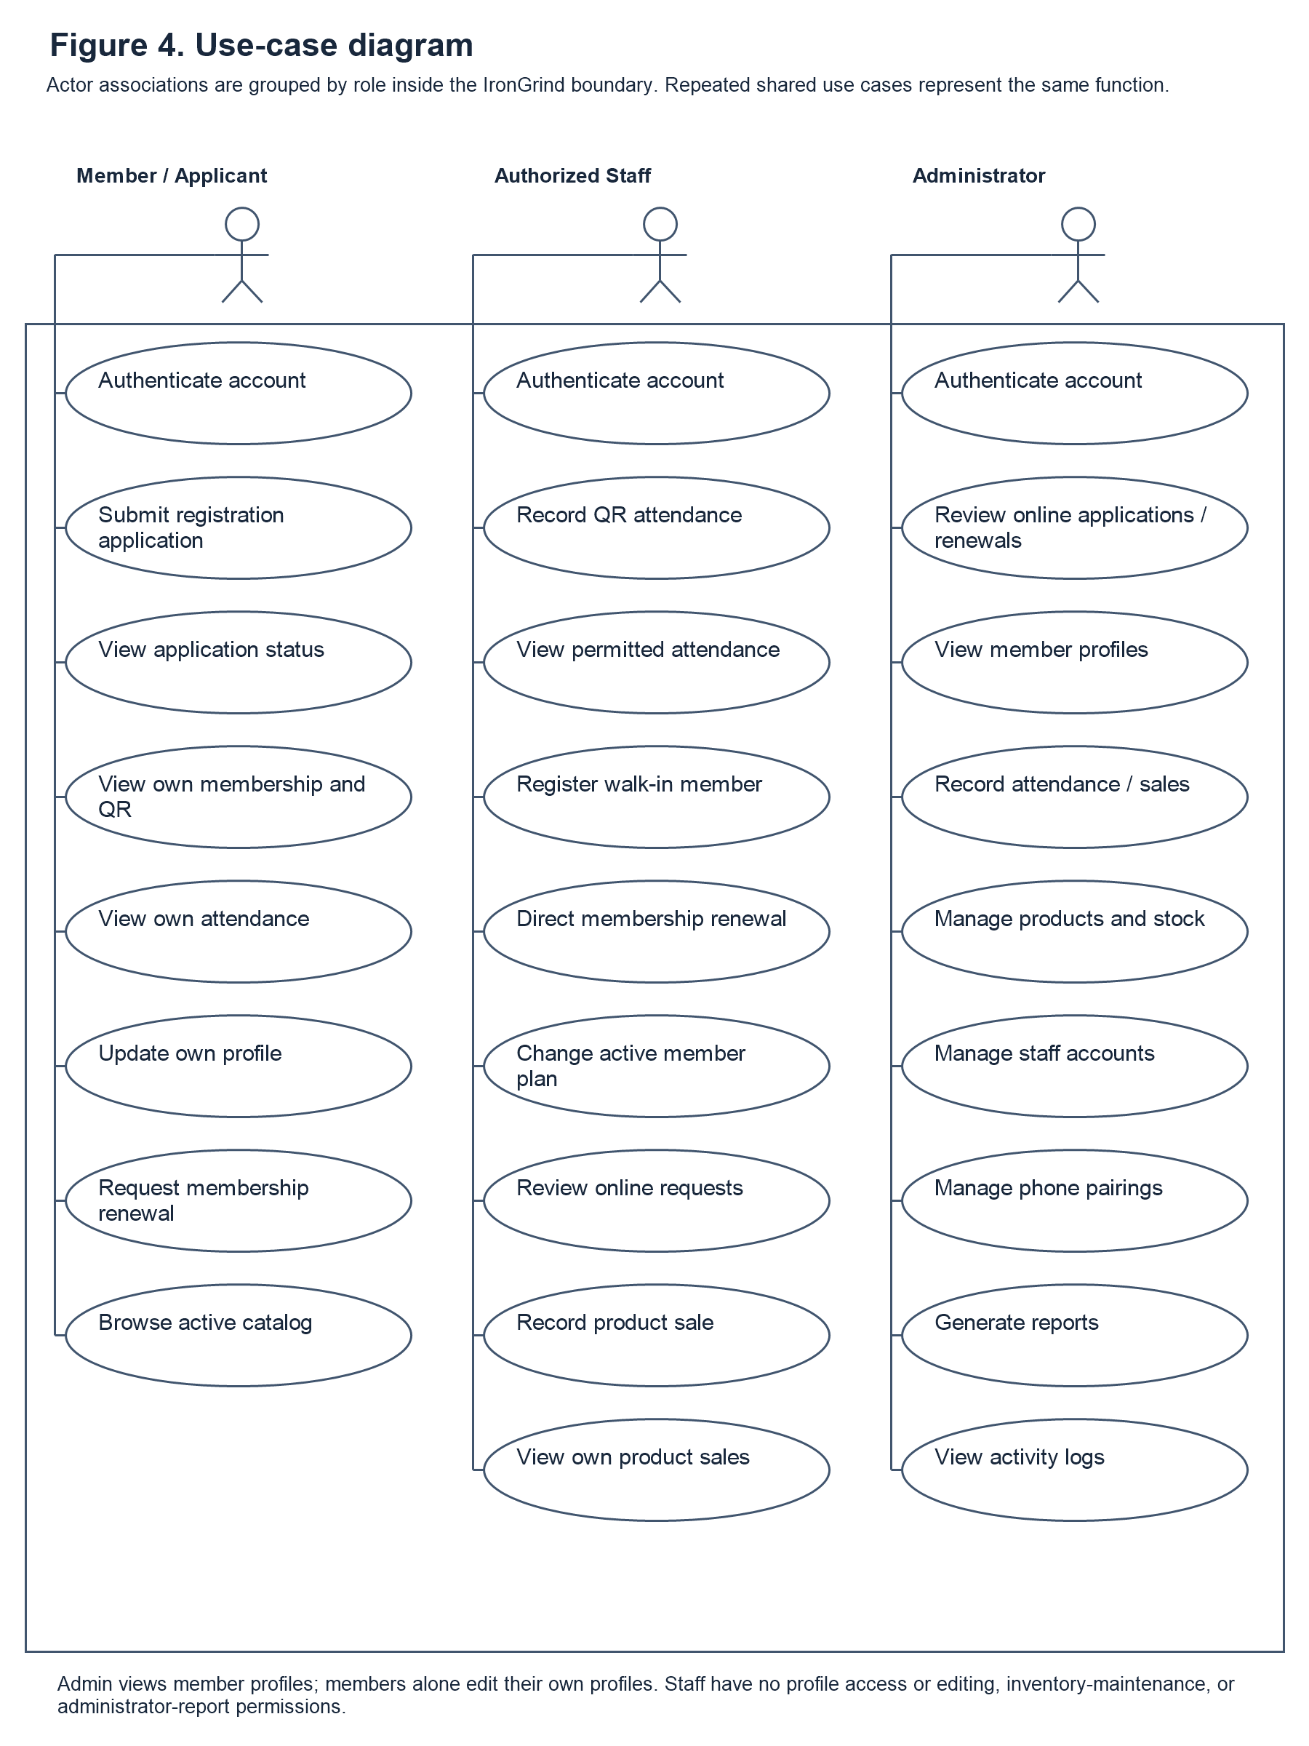
Figure 4. Use Case
Figure 4 describes the system from the perspective of the goals each actor is permitted to accomplish. The stick figures represent the Member / Applicant, Authorized Staff, and Administrator. The ellipses identify use cases, and the association lines connect an actor with the functions available to that role. The system boundary encloses the use cases while the actors remain outside it. Shared functions may appear in more than one role column for readability, but repeated labels refer to the same system capability rather than to separate implementations.
Member and applicant use cases concern registration and personal self-service. An applicant submits an online application and checks its result, while a registered member retrieves their own membership information, displays their QR code, views their attendance history, browses active products, and requests renewal. Only the member can update their own permitted personal-profile details. The administratorâ€™s View Member Profiles use case is therefore distinct from the memberâ€™s Update Own Profile use case: the administrator can inspect the information but cannot change the memberâ€™s personal details.
Staff use cases are limited to attendance and supported counter services. Walk-in registration creates a new account and member record through an authorized service; direct renewal and active-plan change record the selected membership transaction. These functions do not provide staff with a personal-profile screen or an existing-profile editing function. Staff product-sale recording and own-sales review likewise do not grant inventory-maintenance, report, or activity-log access. Both staff and administrator use cases include online registration and renewal review. Administrator use cases additionally cover the permitted operational controls, staff-account administration, phone pairing, reports, and read-only activity-log review. The model describes implemented responsibilities rather than planned business notifications or customer receipt provision. The staff Renewal action allows an operator to find a member, choose the paid renewal plan, and complete the subscription transaction. The Change Plan action allows the operator to find a member and save the selected replacement plan with its price and membership dates. The system records the membership change and associated transaction history. These direct counter actions do not require staff to open a member personal profile and are distinct from online request review, which is also available to authorized staff and the administrator. The Requests approval tab presents pending registration and renewal requests using only the applicant name, request type, selected plan, price, and submission time. The operator confirms payment received at the gym before approval, or rejects the request. An atomic review function verifies the active operator role, locks the request, and rejects repeat processing. Approval creates a new member from the submitted application or extends the linked subscription, records the payment and renewal history when applicable, and saves the reviewer and decision time. Staff cannot use this function to edit existing personal-profile details. The same function is used by the administrator, preventing competing reviews from recording the same request twice.
These use cases outline the specific actions, such as managing membership information, updating records, and generating reports, that contribute to the system's overall functionality. The object model ensures that all necessary functions are clearly defined, organized, and accessible only to authorized users to maintain security and accuracy.
It also serves as a blueprint for system design, making it easier to implement, test, and maintain the system. By providing a structured representation, the model minimizes potential errors and ensures that all user requirements are addressed.
Administrator and staff permissions are shown separately. Staff have no member-profile viewing or personal-detail editing function and do not inherit administrator access to inventory maintenance, staff account controls, phone-pairing administration, reports, or activity logs.
The User is responsible for managing their personal profile, submitting membership applications and renewals, and viewing their attendance history.
Administrators review online applications and renewal requests and manage membership records, products, stock, staff access, phone pairings, activity logs, and reports. Staff record attendance, register walk-in members, perform permitted direct membership changes, record product sales, and review their own product-sale records.
Each of these processes represents a key function of the system, ensuring that gym information is accurately maintained, updated, and easily accessible. These tasks also demonstrate how the system supports efficient documentation, organized data management, and streamlined workflow for gym operations.
1. Authenticate Account
Supabase Auth verifies credentials. The profile role and active-account state determine administrator, staff, or member access, with protected operations checked by server-side authorization. New member registration uses a visible password-strength indicator and blocks passwords that do not meet the Strong requirements: 8 to 128 characters, uppercase and lowercase letters, at least one digit, and at least one symbol. Confirmation must match the selected password. Auth and the member-creation service enforce the password policy on the server; staff-account creation uses a minimum of 12 characters with the same character requirements. Existing sign-in forms continue to accept account credentials without imposing registration validation on login.
2. Register and Submit Membership Application
This function allows the User to create an account and submit their personal and health information, which is then sent to the Admin for review.
3. Review Membership Applications Authorized staff and the administrator review pending application summaries and approve or reject requests according to the gym's criteria, confirming in-person payment before approval.
4. Create or Link Member Account. Approval by an authorized staff member or administrator links an online application to the approved member record. Direct walk-in registration by an authorized administrator or staff operator uses a server-side Edge Function to create the appropriate Auth, profile, member, and payment records.
5. View Application status at Login
The User can check the real-time status of their membership application upon logging in to see if it is pending, approved, or rejected.
6. View Membership Dashboard
This function allows the User to access their personalized dashboard, displaying their active membership plan, time-based progress, and their unique QR code.
7. User Management The administrator can view member profiles but cannot update their personal details. Only members update their own permitted personal profile fields. Administrator membership operations, staff-account controls, and membership-history review are separate from personal-profile editing. Staff have no member-profile viewing or editing function.
8. Record Membership Attendance. An administrator or authorized staff operator scans a member QR code using a supported computer or phone camera. The system records a check-in or check-out and the responsible operator.
9. View Personal Attendance History
The User can view a detailed log of their own gym visits, including the dates and exact times they entered and exited the gym.
10. View and Update Own Profile. A member can view their own profile and update permitted personal details. The administrator may view member profiles but cannot edit them. Staff have no access to member profile viewing or editing.
11. Browse Active Product Catalog
The User can view the available supplements and merchandise sold by the gym.
12. Manage Products and Inventory
The Admin can add, update, and monitor the product catalog, ensuring that merchandise stock quantities and supplement details are accurate.
13. Record Product Sale. An administrator or staff operator records an in-person product purchase, with validated quantities, saved sales and line items, and corresponding stock deduction. Staff can review their own product-sale records. No receipt provision is included in the documented operating process.
14. Submit Membership Renewal Request This function allows a member to submit a renewal request at any time, subject to approval by authorized staff or the administrator. If approved while the membership is active, the new membership duration is added after the current expiry date. If approved after expiration, the renewed period begins on the approval date.
15. View Dashboard and Operational Reports
The Admin can view a summarized dashboard showing active members, daily sales, and attendance, as well as access specific operational reports.
16. Export Reports
This function allows the Admin to generate, download, or print detailed reports for record-keeping and business analysis.
17. Activity Logs and Related Administration. The administrator reviews recorded activity through the Activity Logs use case. Staff-account changes are performed under User Management; phone-pairing changes are performed under QR Attendance administration. These operations generate log entries but are not performed inside the read-only log viewer. Business approval or expiry email notifications are not included as implemented use cases.

Entity Relationship Diagram
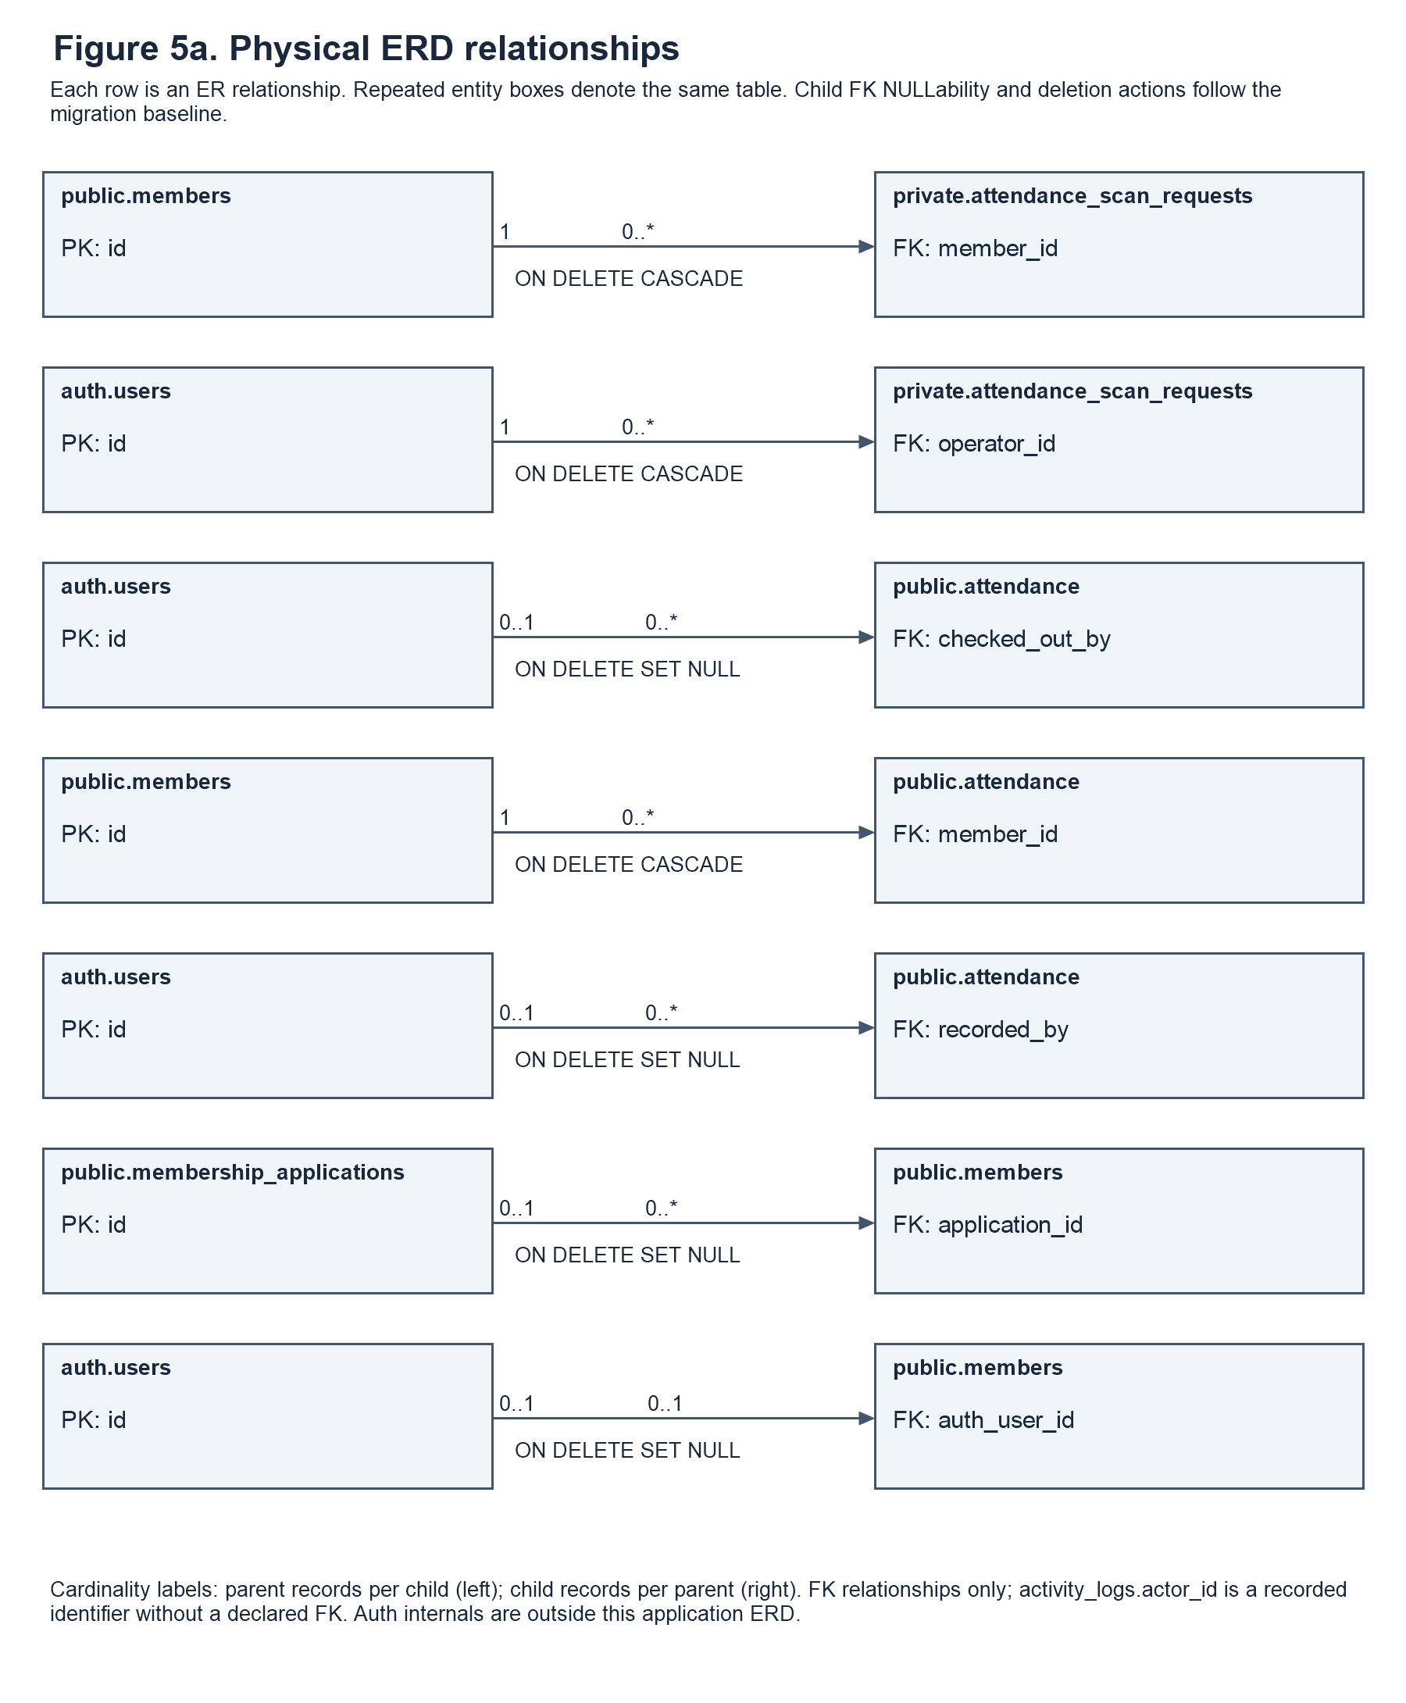

Entity Relationship Diagram
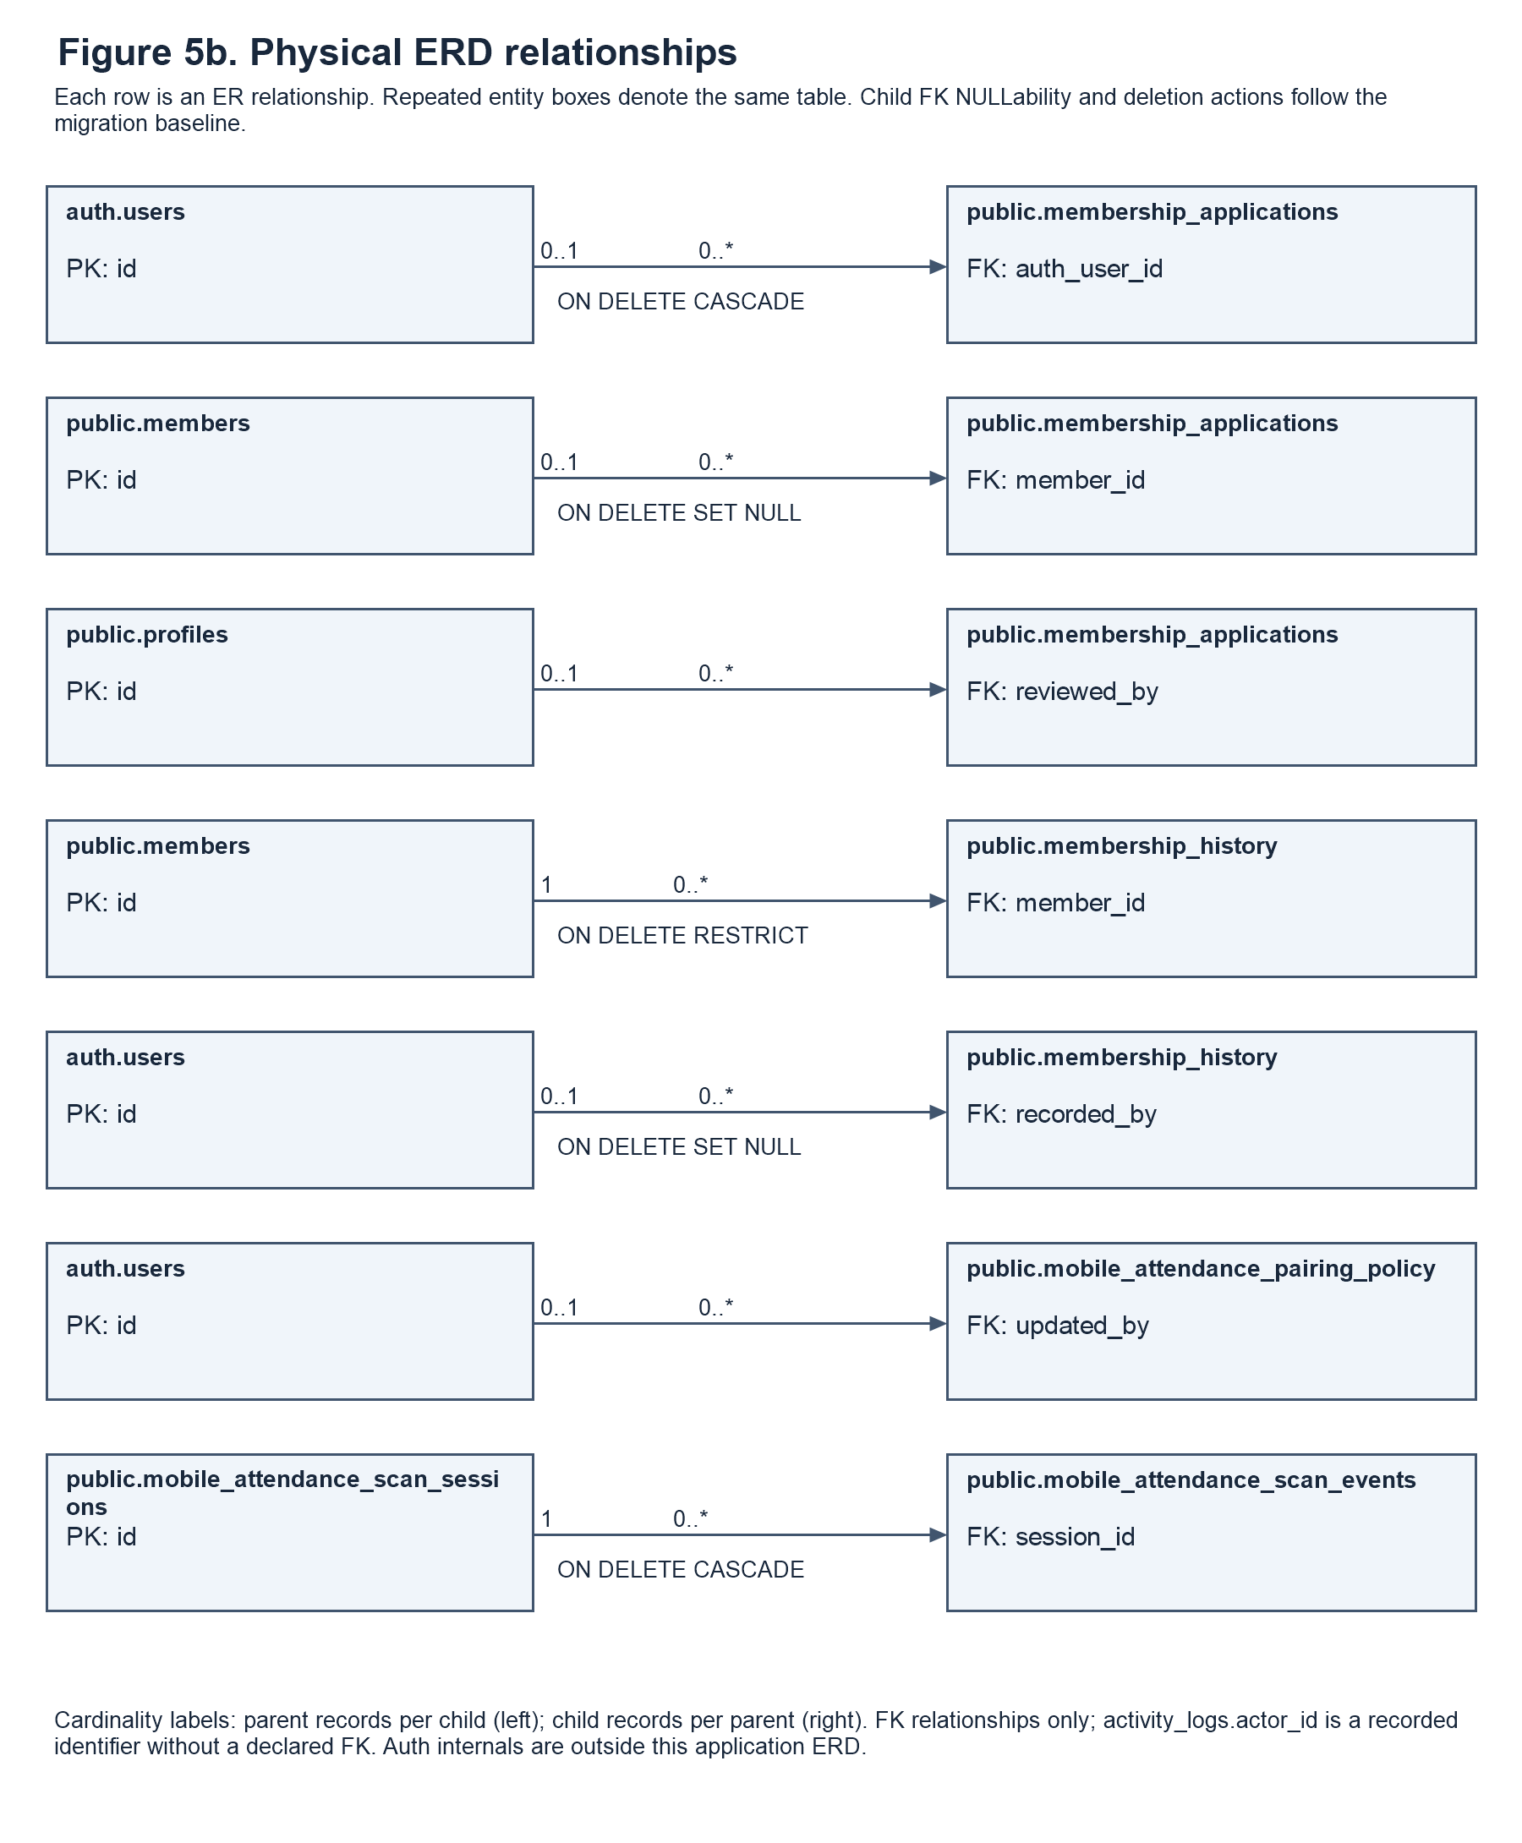

Entity Relationship Diagram
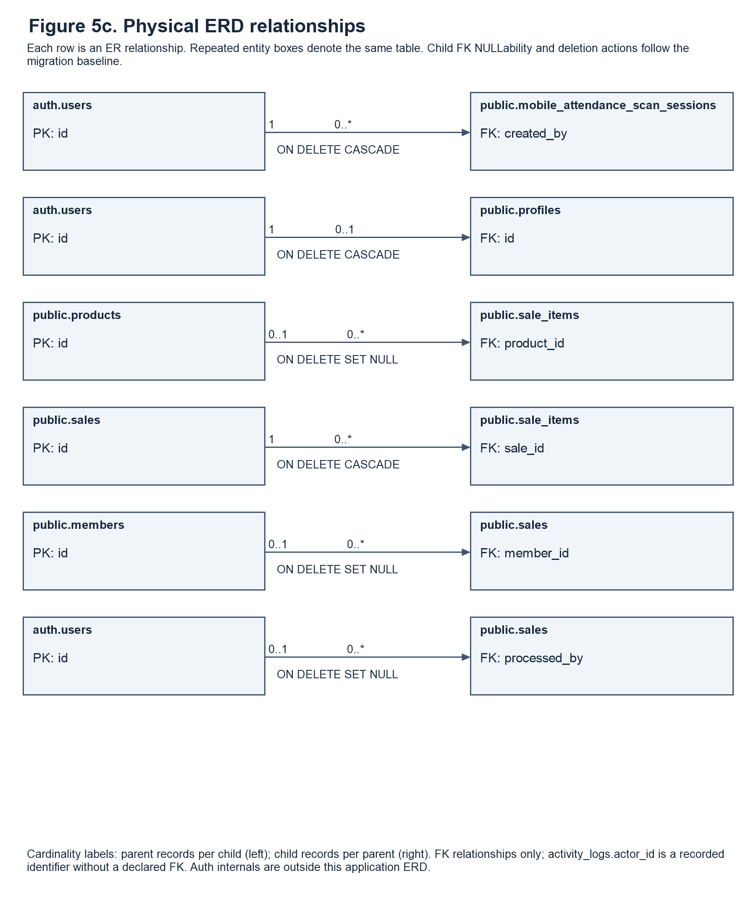
Figure 5a-c. Physical entity relationships
The physical ERD in Figure 5a-c explains the relationships declared in the checked-in database migration baseline. It complements the DFD: the DFD shows how information is processed, whereas the ERD shows how stored records refer to one another. Each relationship row names the parent and child entity, identifies the referenced primary key and child foreign key, and states its cardinality and deletion rule. The panels repeat entity boxes where necessary to keep the relationships readable; repeated names denote the same physical table and should not be counted as additional tables.
Cardinality describes the number of records permitted on either side of a relationship. A required foreign key means that a child record must reference one parent; a nullable foreign key permits the child to exist without that reference. A parent may generally be associated with multiple child records, although a primary key or unique index can restrict a relationship to at most one child. For example, a member may have many attendance records and membership-history events, while the linked Auth-account index permits at most one member record for a particular non-null Auth identifier. An optional sale member reference and an optional sale-line product reference must not be treated as mandatory links.
The core entities preserve different kinds of operational information. Membership applications retain submitted registration or renewal requests and their review status. Members retains the current member and membership values, while membership_history preserves relevant values before and after lifecycle events. Attendance stores visits and the separate operators for check-in and check-out. Sales stores transaction headers, and sale_items stores the individual product or membership charges. Product names and prices captured in sale lines support historical records even when the current catalog changes. The retained receipt_number field is documented as an internal transaction identifier rather than evidence that a customer receipt is issued.
The physical model also includes supporting account, phone-pairing, logging, and attendance-request storage. The dictionary distinguishes twelve public-schema tables from two private supporting tables; managed Auth internals are outside the application-owned table count. The retained mobile_attendance_scan_events table appears because it exists in the baseline, not because a corresponding review interface is available. Deletion rules follow the actual constraints: CASCADE removes dependent rows, SET NULL clears an optional reference, and RESTRICT or the default NO ACTION behavior can prevent a change that would break a relationship. Finally, a foreign-key relationship does not grant an actor permission to view or edit data. Administrator read-only profile viewing, member-only personal editing, and the staff profile restriction remain application authorization rules.
1. auth.users Entity
This entity serves as the primary authentication table for the system. It stores the unique identifier (id) and email address of every user. This entity is crucial for system security, ensuring that only individuals with verified credentials can log in and access the system.
2. profiles Entity. Each profile shares its primary key with auth.users and records the administrator, staff, or member role, account status, active flag, name, username, email, phone number, gender, and timestamps.
3. membership_applications Entity This table stores data from new applicants and renewal requests awaiting review by authorized staff or the administrator. It tracks the application type, selected plan, current status, and submission time. It links to the user applying (auth_user_id) and the staff member or administrator who reviewed it (reviewed_by).
4. members Entity
The members table stores each member’s personal information, current membership plan, membership dates, status, and registration source. It links to the member’s Supabase Auth account and may reference a registration application. The application reference can be empty for members created directly by an administrator.
5. attendance Entity. Each visit references a member and stores its date and check-in and optional check-out timestamps. recorded_by and checked_out_by independently reference the Auth accounts responsible for the two attendance events.
6. products Entity. Products store category, price, stock, stock and sale units, supplement form and type, merchandise type, size, active or archived state, and image reference. Stock is numeric and supports product-appropriate weight, volume, piece, box, or item units.
7. sales Entity. Each row stores a transaction total, customer details, optional member reference, status, sold_at timestamp, and processing Auth account. The retained receipt_number column is an internal transaction reference; its technical name does not mean that a receipt is provided to the customer.
8. sale_items Entity. Each line belongs to one sale and optionally references a product. It preserves the item or membership label, category, quantity, unit, price, and line total. Membership charges have no product reference, and historical item labels remain available if a product reference becomes NULL.
9. membership_history Entity. History records reference a member and optionally the responsible Auth account. They retain renewal, plan-change, or expiry events and the membership values before and after the event.
Auth Users to Profiles and Members. An Auth account can have at most one profile and at most one linked member record. Each profile requires an Auth account; a member record can exist without an Auth link. Administrator, staff, and pending-applicant accounts need not have a linked member record.
Members to Membership Applications. This is a one-to-many relationship: a member can have multiple membership applications over time, including renewal requests. Each application may reference one member. A pending registration application can exist without a linked member record until it is processed.
Members to Attendance. This is a one-to-many relationship because a member can have multiple attendance logs (check-ins) over their membership period, but each attendance record is tied to only one member.
Members to Sales. This is a one-to-many relationship because a member can make multiple product purchases (sales), but each sale is tied to only one member (if it is not a walk-in).
Members to Membership History. This is a one-to-many relationship because a member can have multiple history records (renewals, plan changes) over time, but each history record is linked to only one member.
Sales to Sale_Items. This is a one-to-many relationship because a single sales transaction can contain multiple items (sale_items), but each sale_item belongs to only one sale.
Products to Sale_Items. A product can appear in multiple sale items. Each sale item may reference one product, while membership charges have no product reference. The item name and price are retained as transaction snapshots
Supporting Relationships. Online application reviewed_by references profiles, while attendance and transaction operator fields reference auth.users. Phone sessions reference their creator, scan events reference their session, and pairing policy optionally references its updating Auth user. Private attendance_scan_requests references an operator and member. activity_logs.actor_id is a stored actor identifier without a declared foreign key; it is not drawn as an enforced relationship.
Overall Description
The ERD includes core membership and transaction relationships and supporting identity and phone-attendance relationships. Nullable references permit walk-in sales without a member, membership charges without a product, and membership records without an Auth account. Referential actions follow the baseline: attendance.member_id cascades on member deletion, while membership_history.member_id restricts deletion. The dictionary below lists actual column types, NULLability, and declared keys from the same baseline rather than assuming that similarly named fields have identical types.

Data Dictionary
The Length / Precision / Scale column reports declared storage limits rather than invented form limits. For character varying(n), n is the maximum character count. For numeric(p,s), p is the total digit precision and s is the number of decimal places; for example, numeric(12,2) allows ten digits before and two digits after the decimal point. Not declared indicates a text, text-array, or JSON column without a declared character maximum, while N/A identifies a type such as UUID, date, timestamp, Boolean, or integer that does not use a character-length parameter. Separate database checks and verified form or function limits are explained in the description. A UUIDâ€™s conventional displayed format is not a varchar length, and the number of characters used to display a date is not a database date-column length.
The Length / Precision / Scale column reports declared storage limits rather than invented form limits. For character varying(n), n is the maximum character count. For numeric(p,s), p is the total digit precision and s is the number of decimal places; for example, numeric(12,2) allows ten digits before and two digits after the decimal point. Not declared indicates a text, text-array, or JSON column without a declared character maximum, while N/A identifies a type such as UUID, date, timestamp, Boolean, or integer that does not use a character-length parameter. Separate database checks and verified form or function limits are explained in the description. A UUIDâ€™s conventional displayed format is not a varchar length, and the number of characters used to display a date is not a database date-column length.
Table 6: profile
Stores account-facing profile details, administrator/staff/member roles, account status, active-account controls, contact details, and timestamps.
Field Name | Field Type | Length / Precision / Scale | Key | Description and Validation Details
id | uuid | N/A | PK, FK | Uniquely identifies this record so that the system can retrieve it and relate it to other operational information without relying on a person or product name. Required.
username | character varying | 30 |  | Stores the application username used to identify an account within supported sign-in and member-lookup workflows. Nullable.
full_name | character varying | 150 |  | Stores the complete name submitted for the account, application, or member. Required.
role | character varying | 20 |  | Identifies the account role as admin, staff, or member. Required.
account_status | text | Not declared |  | Stores the account-state value as pending, active, or disabled according to its database check constraint. Required.
created_at | timestamptz | N/A |  | Records when the database record was created. Required.
updated_at | timestamptz | N/A |  | Records the timestamp used to identify the latest update to the record. Required.
email | character varying | 254 |  | Stores the email address associated with the account or submitted record. Nullable.
is_active | boolean | N/A |  | Indicates whether the account or catalog record is enabled for its applicable workflow. Required.
phone_number | text | Not declared |  | Stores contact information for the account. Nullable.
gender | text | Not declared |  | Stores the gender value supplied for an account through the supported form. Nullable.
Table 7: members
Stores each gym member's current personal details and membership information. Previous membership changes are recorded separately in `membership_history`.
Field Name | Field Type | Length / Precision / Scale | Key | Description and Validation Details
id | uuid | N/A | PK | Uniquely identifies this record so that the system can retrieve it and relate it to other operational information without relying on a person or product name. Required.
application_id | uuid | N/A | FK | Links a member record to the associated registration application when one exists. Nullable.
full_name | character varying | 150 |  | Stores the complete name submitted for the account, application, or member. Required.
mobile | character varying | 11 |  | Stores a Philippine mobile contact number for the member or applicant. Nullable.
plan | character varying | 30 |  | Stores the name of the membership plan associated with the record. Required.
start_date | date | N/A |  | Records the starting calendar date of the requested or current membership period. Nullable.
end_date | date | N/A |  | Stores the membership end date retained by current and compatibility operations. Nullable.
status | character varying | 20 |  | Stores the lifecycle or transaction state of the record. Required.
paid | numeric | 10,2 |  | Stores the recorded membership payment amount as a number. Required.
fitness_goals | text[] | Not declared |  | Stores the selected fitness-goal entries as an array of text values. Required.
height | numeric | 6,2 |  | Stores the submitted height measurement as a decimal number. Nullable.
height_unit | character varying | 3 |  | Identifies the unit associated with the height measurement. Nullable.
weight | numeric | 6,2 |  | Retains a compatibility weight measurement used by earlier or supporting data paths. Nullable.
health_conditions | text[] | Not declared |  | Stores declared health-condition entries as an array of text values. Required.
other_medical_conditions | text | Not declared |  | Stores additional health-condition details supplied by the person. Nullable.
signature_data | text | Not declared |  | Retains signature data submitted through the registration workflow. Nullable.
created_at | timestamptz | N/A |  | Records when the database record was created. Required.
auth_user_id | uuid | N/A | FK | Links the record to a managed Supabase Auth account. Nullable.
email | character varying | 254 |  | Stores the email address associated with the account or submitted record. Nullable.
username | character varying | 30 |  | Stores the application username used to identify an account within supported sign-in and member-lookup workflows. Nullable.
date_of_birth | date | N/A |  | Records the personâ€™s birth date for registration and personal-information records. Nullable.
age | smallint | N/A |  | Stores the recorded age value associated with the person. Nullable.
sex | character varying | 30 |  | Stores the sex value submitted in the member or application form. Nullable.
weight_kg | numeric | 7,2 |  | Stores the personâ€™s weight in kilograms as a decimal measurement. Nullable.
emergency_contact | jsonb | Not declared |  | Stores emergency-contact information. Required.
plan_price | numeric | 12,2 |  | Stores the monetary amount associated with the selected membership plan. Required.
expiry_date | date | N/A |  | Stores the explicit expiration date of the memberâ€™s recorded membership period. Nullable.
registration_source | character varying | 40 |  | Identifies the workflow through which the member record was created, such as online application or an authorized counter registration. Required.
signature_path | text | Not declared |  | Stores a signature reference or payload used by the applicable workflow. Nullable.
updated_at | timestamptz | N/A |  | Records the timestamp used to identify the latest update to the record. Required.
Table 8: membership_applications
Stores submitted registration and renewal requests with the information provided by the applicant. Review status, reviewer, and timestamps track each request through processing.
Field Name | Field Type | Length / Precision / Scale | Key | Description and Validation Details
id | uuid | N/A | PK | Uniquely identifies this record so that the system can retrieve it and relate it to other operational information without relying on a person or product name. Required.
full_name | character varying | 150 |  | Stores the complete name submitted for the account, application, or member. Required.
date_of_birth | date | N/A |  | Records the personâ€™s birth date for registration and personal-information records. Nullable.
age | integer | N/A |  | Stores the recorded age value associated with the person. Nullable.
sex | character varying | 30 |  | Stores the sex value submitted in the member or application form. Nullable.
mobile | character varying | 11 |  | Stores a Philippine mobile contact number for the member or applicant. Nullable.
height | numeric | 6,2 |  | Stores the submitted height measurement as a decimal number. Nullable.
height_unit | character varying | 3 |  | Identifies the unit associated with the height measurement. Nullable.
weight | numeric | 6,2 |  | Retains a compatibility weight measurement used by earlier or supporting data paths. Nullable.
emergency_name | text | Not declared |  | Retains the emergency contact personâ€™s name submitted with an application. Nullable.
emergency_relationship | text | Not declared |  | Retains the applicantâ€™s relationship to the emergency contact person. Nullable.
emergency_contact | text | Not declared |  | Stores emergency-contact information. Nullable.
plan | character varying | 30 |  | Stores the name of the membership plan associated with the record. Required.
plan_price | numeric | 10,2 |  | Stores the monetary amount associated with the selected membership plan. Required.
start_date | date | N/A |  | Records the starting calendar date of the requested or current membership period. Nullable.
end_date | date | N/A |  | Stores the membership end date retained by current and compatibility operations. Nullable.
health_conditions | text[] | Not declared |  | Stores declared health-condition entries as an array of text values. Required.
other_medical_conditions | text | Not declared |  | Stores additional health-condition details supplied by the person. Nullable.
fitness_goals | text[] | Not declared |  | Stores the selected fitness-goal entries as an array of text values. Required.
signature_data | text | Not declared |  | Retains signature data submitted through the registration workflow. Nullable.
status | character varying | 20 |  | Stores the lifecycle or transaction state of the record. Required.
reviewed_by | uuid | N/A | FK | Identifies the profile of the staff member or administrator who reviewed the application. Nullable.
reviewed_at | timestamptz | N/A |  | Records when the staff member or administrator reviewed the request. Nullable.
created_at | timestamptz | N/A |  | Records when the database record was created. Required.
auth_user_id | uuid | N/A | FK | Links the record to a managed Supabase Auth account. Nullable.
member_id | uuid | N/A | FK | Identifies the member related to this operational record. Nullable.
application_type | character varying | 20 |  | Distinguishes an initial registration application from a membership renewal request. Required.
submitted_at | timestamptz | N/A |  | Records the submission timestamp associated with an application. Required.
email | character varying | 254 |  | Stores the email address associated with the account or submitted record. Nullable.
username | character varying | 30 |  | Stores the application username used to identify an account within supported sign-in and member-lookup workflows. Nullable.
emergency_contact_data | jsonb | Not declared |  | Stores the structured emergency-contact payload associated with an application. Required.
weight_kg | numeric | 7,2 |  | Stores the personâ€™s weight in kilograms as a decimal measurement. Nullable.
signature_path | text | Not declared |  | Stores a signature reference or payload used by the applicable workflow. Nullable.
Table 9: attendance
Stores one record for each member visit to the gym. Check-in and optional check-out timestamps support attendance history and visit tracking.
Field Name | Field Type | Length / Precision / Scale | Key | Description and Validation Details
id | uuid | N/A | PK | Uniquely identifies this record so that the system can retrieve it and relate it to other operational information without relying on a person or product name. Required.
member_id | uuid | N/A | FK | Identifies the member related to this operational record. Required.
date | date | N/A |  | Stores the date associated with the attendance row. Required.
time_in | timestamptz | N/A |  | Records when the visit began. Required.
time_out | timestamptz | N/A |  | Records when the visit ended. Nullable.
created_at | timestamptz | N/A |  | Records when the database record was created. Required.
recorded_by | uuid | N/A | FK | Identifies the Auth account responsible for recording the attendance or history event. Nullable.
checked_out_by | uuid | N/A | FK | Identifies the Auth account that recorded check-out. Nullable.
Table 10: products
Stores products offered for sale, including prices, units, and inventory information. Active and archived product records support catalog management and sales history.
Field Name | Field Type | Length / Precision / Scale | Key | Description and Validation Details
id | uuid | N/A | PK | Uniquely identifies this record so that the system can retrieve it and relate it to other operational information without relying on a person or product name. Required.
name | character varying | 120 |  | Stores the productâ€™s catalog name used in inventory and product selection. Required.
category | character varying | 20 |  | Classifies the product or sale line for the appropriate operational behavior. Required.
price | numeric | 10,2 |  | Retains the product price field declared in the physical schema. Required.
stock | numeric | 14,6 |  | Stores the available product quantity using the configured inventory unit. Required.
size | character varying | 30 |  | Stores an optional size or package description used to distinguish applicable merchandise or products. Nullable.
created_at | timestamptz | N/A |  | Records when the database record was created. Required.
updated_at | timestamptz | N/A |  | Records the timestamp used to identify the latest update to the record. Required.
is_active | boolean | N/A |  | Indicates whether the account or catalog record is enabled for its applicable workflow. Required.
archived_at | timestamptz | N/A |  | Records when a product was archived, when applicable. Nullable.
image_path | text | Not declared |  | Stores the catalog image reference associated with the product. Nullable.
price_per_unit | numeric | 12,2 |  | Stores the product price for the configured pricing unit. Required.
unit | character varying | 12 |  | Identifies the unit associated with a product price or sale-line quantity. Required.
stock_unit | text | Not declared |  | Identifies the unit in which inventory quantities are recorded. Required.
merch_type | text | Not declared |  | Identifies the merchandise classification, such as apparel, accessories, drinkware, gym_gear, or other. Nullable.
supplement_form | text | Not declared |  | Identifies the supplement form as powder, drinkable, capsule, tablet, or other where applicable. Nullable.
supplement_type | text | Not declared |  | Classifies a supplement as protein, creatine, pre_workout, vitamins, amino_acids, or other. Nullable.
Table 11: sales
Stores one transaction header with customer details, amount, status, optional member reference, internal transaction identifier, and processing operator.
Field Name | Field Type | Length / Precision / Scale | Key | Description and Validation Details
id | uuid | N/A | PK | Uniquely identifies this record so that the system can retrieve it and relate it to other operational information without relying on a person or product name. Required.
member_id | uuid | N/A | FK | Identifies the member related to this operational record. Nullable.
customer_name | character varying | 150 |  | Preserves the customer name supplied for the transaction. Required.
items | jsonb | Not declared |  | Retains a JSON transaction-item payload in the sales header. Required.
total | numeric | 10,2 |  | Stores the complete transaction amount in the sale header. Required.
status | character varying | 12 |  | Stores the lifecycle or transaction state of the record. Required.
sold_at | timestamptz | N/A |  | Records the transaction timestamp. Required.
receipt_number | character varying | 64 |  | Stores the existing internal transaction reference under its retained database column name. Required.
customer_type | character varying | 15 |  | Stores the customer classification recorded for the sale. Required.
processed_by | uuid | N/A | FK | Identifies the Auth account of the authorized operator who recorded the transaction. Nullable.
Table 12: sale_items
Stores each product or membership charge associated with a sale. Item name and price are retained as a transaction snapshot if the catalog record later changes or is removed.
Field Name | Field Type | Length / Precision / Scale | Key | Description and Validation Details
id | uuid | N/A | PK | Uniquely identifies this record so that the system can retrieve it and relate it to other operational information without relying on a person or product name. Required.
sale_id | uuid | N/A | FK | Links each sale line to its transaction header. Required.
product_id | uuid | N/A | FK | Links a sale line to its catalog product when applicable. Nullable.
item_name | character varying | 150 |  | Preserves the product or membership label as it was recorded for the transaction line. Required.
category | character varying | 20 |  | Classifies the product or sale line for the appropriate operational behavior. Required.
quantity | numeric | 12,3 |  | Stores the quantity charged for a sale line, including fractional amounts where supported. Required.
unit | character varying | 12 |  | Identifies the unit associated with a product price or sale-line quantity. Required.
unit_price | numeric | 12,2 |  | Stores the price charged per recorded sale unit. Required.
line_total | numeric | 12,2 |  | Stores the amount charged for an individual sale line. Required.
Table 13: membership_history
Stores membership lifecycle events and the relevant membership values before and after each event. These records support administrative review and reporting without replacing the member's current details.
Field Name | Field Type | Length / Precision / Scale | Key | Description and Validation Details
id | uuid | N/A | PK | Uniquely identifies this record so that the system can retrieve it and relate it to other operational information without relying on a person or product name. Required.
member_id | uuid | N/A | FK | Identifies the member related to this operational record. Required.
event_type | character varying | 30 |  | Identifies the membership-history event as expired, renewal, or plan_change. Required.
previous_plan | character varying | 30 |  | Records the plan before the membership-history event. Nullable.
new_plan | character varying | 30 |  | Records the plan associated with the membership after the recorded event. Nullable.
previous_price | numeric | 12,2 |  | Stores the membership price before the recorded event. Nullable.
new_price | numeric | 12,2 |  | Stores the membership price after the recorded event. Nullable.
previous_start_date | date | N/A |  | Preserves the membership start date before the history event. Nullable.
previous_expiry_date | date | N/A |  | Preserves the membership expiry date before the history event. Nullable.
new_start_date | date | N/A |  | Records the start date after the membership-history event. Nullable.
new_expiry_date | date | N/A |  | Records the expiry date after the membership-history event. Nullable.
notes | text | Not declared |  | Stores supporting context about the membership-history event. Required.
recorded_at | timestamptz | N/A |  | Records when the membership-history event was saved. Required.
recorded_by | uuid | N/A | FK | Identifies the Auth account responsible for recording the attendance or history event. Nullable.
Table 14: public.activity_logs
Field Name | Field Type | Length / Precision / Scale | Key | Description and Validation Details
id | bigint | N/A | PK | Uniquely identifies this record so that the system can retrieve it and relate it to other operational information without relying on a person or product name. Required.
occurred_at | timestamptz | N/A |  | Records when the activity entry was captured. Required.
actor_id | uuid | N/A |  | Retains the identifier of the account responsible for the logged operation. Nullable.
actor_name | text | Not declared |  | Preserves the actor name captured with the activity entry. Required.
actor_role | text | Not declared |  | Preserves the role captured when the activity was recorded. Required.
action | text | Not declared |  | Identifies the recorded action, such as creation, update, approval, check-in, or a phone-pairing event. Required.
entity_type | text | Not declared |  | Identifies the system area or table associated with the logged action. Required.
entity_id | text | Not declared |  | Stores the identifier of the affected record when one is available. Nullable.
record_label | text | Not declared |  | Stores a readable label for the affected record. Required.
changed_fields | text[] | Not declared |  | Stores the field names associated with a recorded change as a text array. Required.
details | text | Not declared |  | Stores a descriptive account of the logged action. Required.
Table 15: public.mobile_attendance_pairing_policy
Field Name | Field Type | Length / Precision / Scale | Key | Description and Validation Details
singleton | boolean | N/A | PK | Identifies the single configuration row for the phone-pairing policy. Required.
max_pairs | integer | N/A |  | Stores the maximum number of paired attendance phones permitted by the policy. Required.
updated_at | timestamptz | N/A |  | Records the timestamp used to identify the latest update to the record. Required.
updated_by | uuid | N/A | FK | Identifies the Auth account responsible for the recorded policy update. Nullable.
pairing_password_hash | text | Not declared |  | Stores the hashed pairing password used by the authorized phone-pairing workflow. Nullable.
pairing_removal_pin_hash | text | Not declared |  | Stores the hashed PIN used to authorize pairing removal. Nullable.
Table 16: public.mobile_attendance_scan_sessions
Field Name | Field Type | Length / Precision / Scale | Key | Description and Validation Details
id | uuid | N/A | PK | Uniquely identifies this record so that the system can retrieve it and relate it to other operational information without relying on a person or product name. Required.
token_hash | text | Not declared |  | Stores the hashed pairing token associated with the phone session. Required.
created_by | uuid | N/A | FK | Identifies the Auth account of the administrator who created the phone-pairing session. Required.
created_at | timestamptz | N/A |  | Records when the database record was created. Required.
expires_at | timestamptz | N/A |  | Records when the pairing session expires. Required.
paired_device | text | Not declared |  | Stores the descriptive label of the paired phone. Nullable.
paired_at | timestamptz | N/A |  | Records when the phone was paired. Nullable.
remember_phone | boolean | N/A |  | Indicates whether the pairing was created with the remembered-phone option. Required.
Table 17: public.mobile_attendance_scan_events
Field Name | Field Type | Length / Precision / Scale | Key | Description and Validation Details
id | uuid | N/A | PK | Uniquely identifies this record so that the system can retrieve it and relate it to other operational information without relying on a person or product name. Required.
session_id | uuid | N/A | FK | Links a retained scan-event record to its associated phone-pairing session. Required.
qr_payload | text | 1-500 (CHECK) |  | Stores the QR payload retained in the scan-event table. Required.
created_at | timestamptz | N/A |  | Records when the database record was created. Required.
Table 18: private.attendance_scan_requests
Field Name | Field Type | Length / Precision / Scale | Key | Description and Validation Details
request_id | uuid | N/A | PK | Stores the unique request identifier used for duplicate attendance-request protection. Required.
operator_id | uuid | N/A | FK | Identifies the Auth account that submitted the attendance request. Required.
member_id | uuid | N/A | FK | Identifies the member related to this operational record. Required.
result | jsonb | Not declared |  | Stores the saved attendance-processing result as structured JSON. Required.
created_at | timestamptz | N/A |  | Records when the database record was created. Required.
Table 19: private.admin_login_attempts
Field Name | Field Type | Length / Precision / Scale | Key | Description and Validation Details
bucket | text | Not declared | PK | Identifies the grouping used by the private administrator-login attempt tracker. Required.
window_start | timestamptz | N/A |  | Records the beginning of the attempt-tracking window. Required.
attempts | integer | N/A |  | Stores the number of attempts recorded for the associated tracking window. Required.

Forms
The system uses registration, profile, renewal, member, inventory, sales, staff-account, and phone-pairing forms. Members submit online registration or renewal information and maintain their permitted profile details. Administrators review online requests, maintain products and stock, and manage staff and pairing access. Authorized staff use counter forms for walk-in registration, direct renewal, active-member plan change, and product purchases, and use Requests approval for online registration and renewal decisions. Attendance uses camera scanning under an authorized operator account. Completed payments and purchases are recorded as transactions; receipts are not provided to customers. Required fields, validation, and server-side role checks support consistent data entry.

Prototype

Figure 6. log-in dashboard
Login. Members, staff, and administrators sign in through the supported account workflow. Applicants can register, and account holders can access password recovery.

Figure 7. Member Registration dashboard
Membership Registration The upper section collects personal details, emergency contact, plan, health information, and goals. The lower section contains agreements, signature, and account credentials. Submissions go to authorized staff or the administrator for review.

Figure 8. Admin dashboard
Admin Dashboard Shows a quick summary of current members, today’s visits and sales, and low-stock products. The sidebar opens the admin pages.

Figure 9. User Management dashboard
User Management Searches and filters members by plan. Admins can add members, change plans, renew memberships, and review pending applications.

Figure 10. Attendance & QR dashboard
Attendance & QR Staff scan a member’s QR code to check them in. Scanning again checks them out. The log shows visits for the selected date.

Figure 11. Store & Inventory dashboard
Store and Inventory. Administrators add, update, restock, or archive products. Authorized staff can record product sales from their permitted catalog but cannot maintain inventory records.

Figure 12. Sales (Memberships)
Membership Sales. Administrators review recorded membership income and transaction counts for the selected period and plan. The transaction identifier supports internal record retrieval; customer receipt provision is outside the documented process.

Figure 13. Sales (Products)
Product Sales. Administrators review product-income totals and transaction records and record new purchases. Staff record product purchases through their own portal and review their own product-sale records.

Figure 14. Reports dashboard
Reports Provides membership, attendance, sales, renewal, archive, and inventory reports. Reports can be viewed, printed, saved as PDFs, or exported together.

Figure 15. Report Preview
Report Preview Shows a report inside the app. Users can scroll, zoom, or close the preview.

Figure 16. Final Report Print
Final Report Print Preview Shows how the report will appear on the page before saving or printing.

Figure 17. Member dashboard
Member Dashboard Members can check their plan, expiry, progress, attendance, renewal options, products available at the gym, and personal QR code.

Figure 18. Member Account Settings
Account Settings Lets members review or update personal, emergency-contact, fitness, and health details.

Figure 19. Member QR Code
Member QR Code The member presents this code at the gym so staff can record attendance.
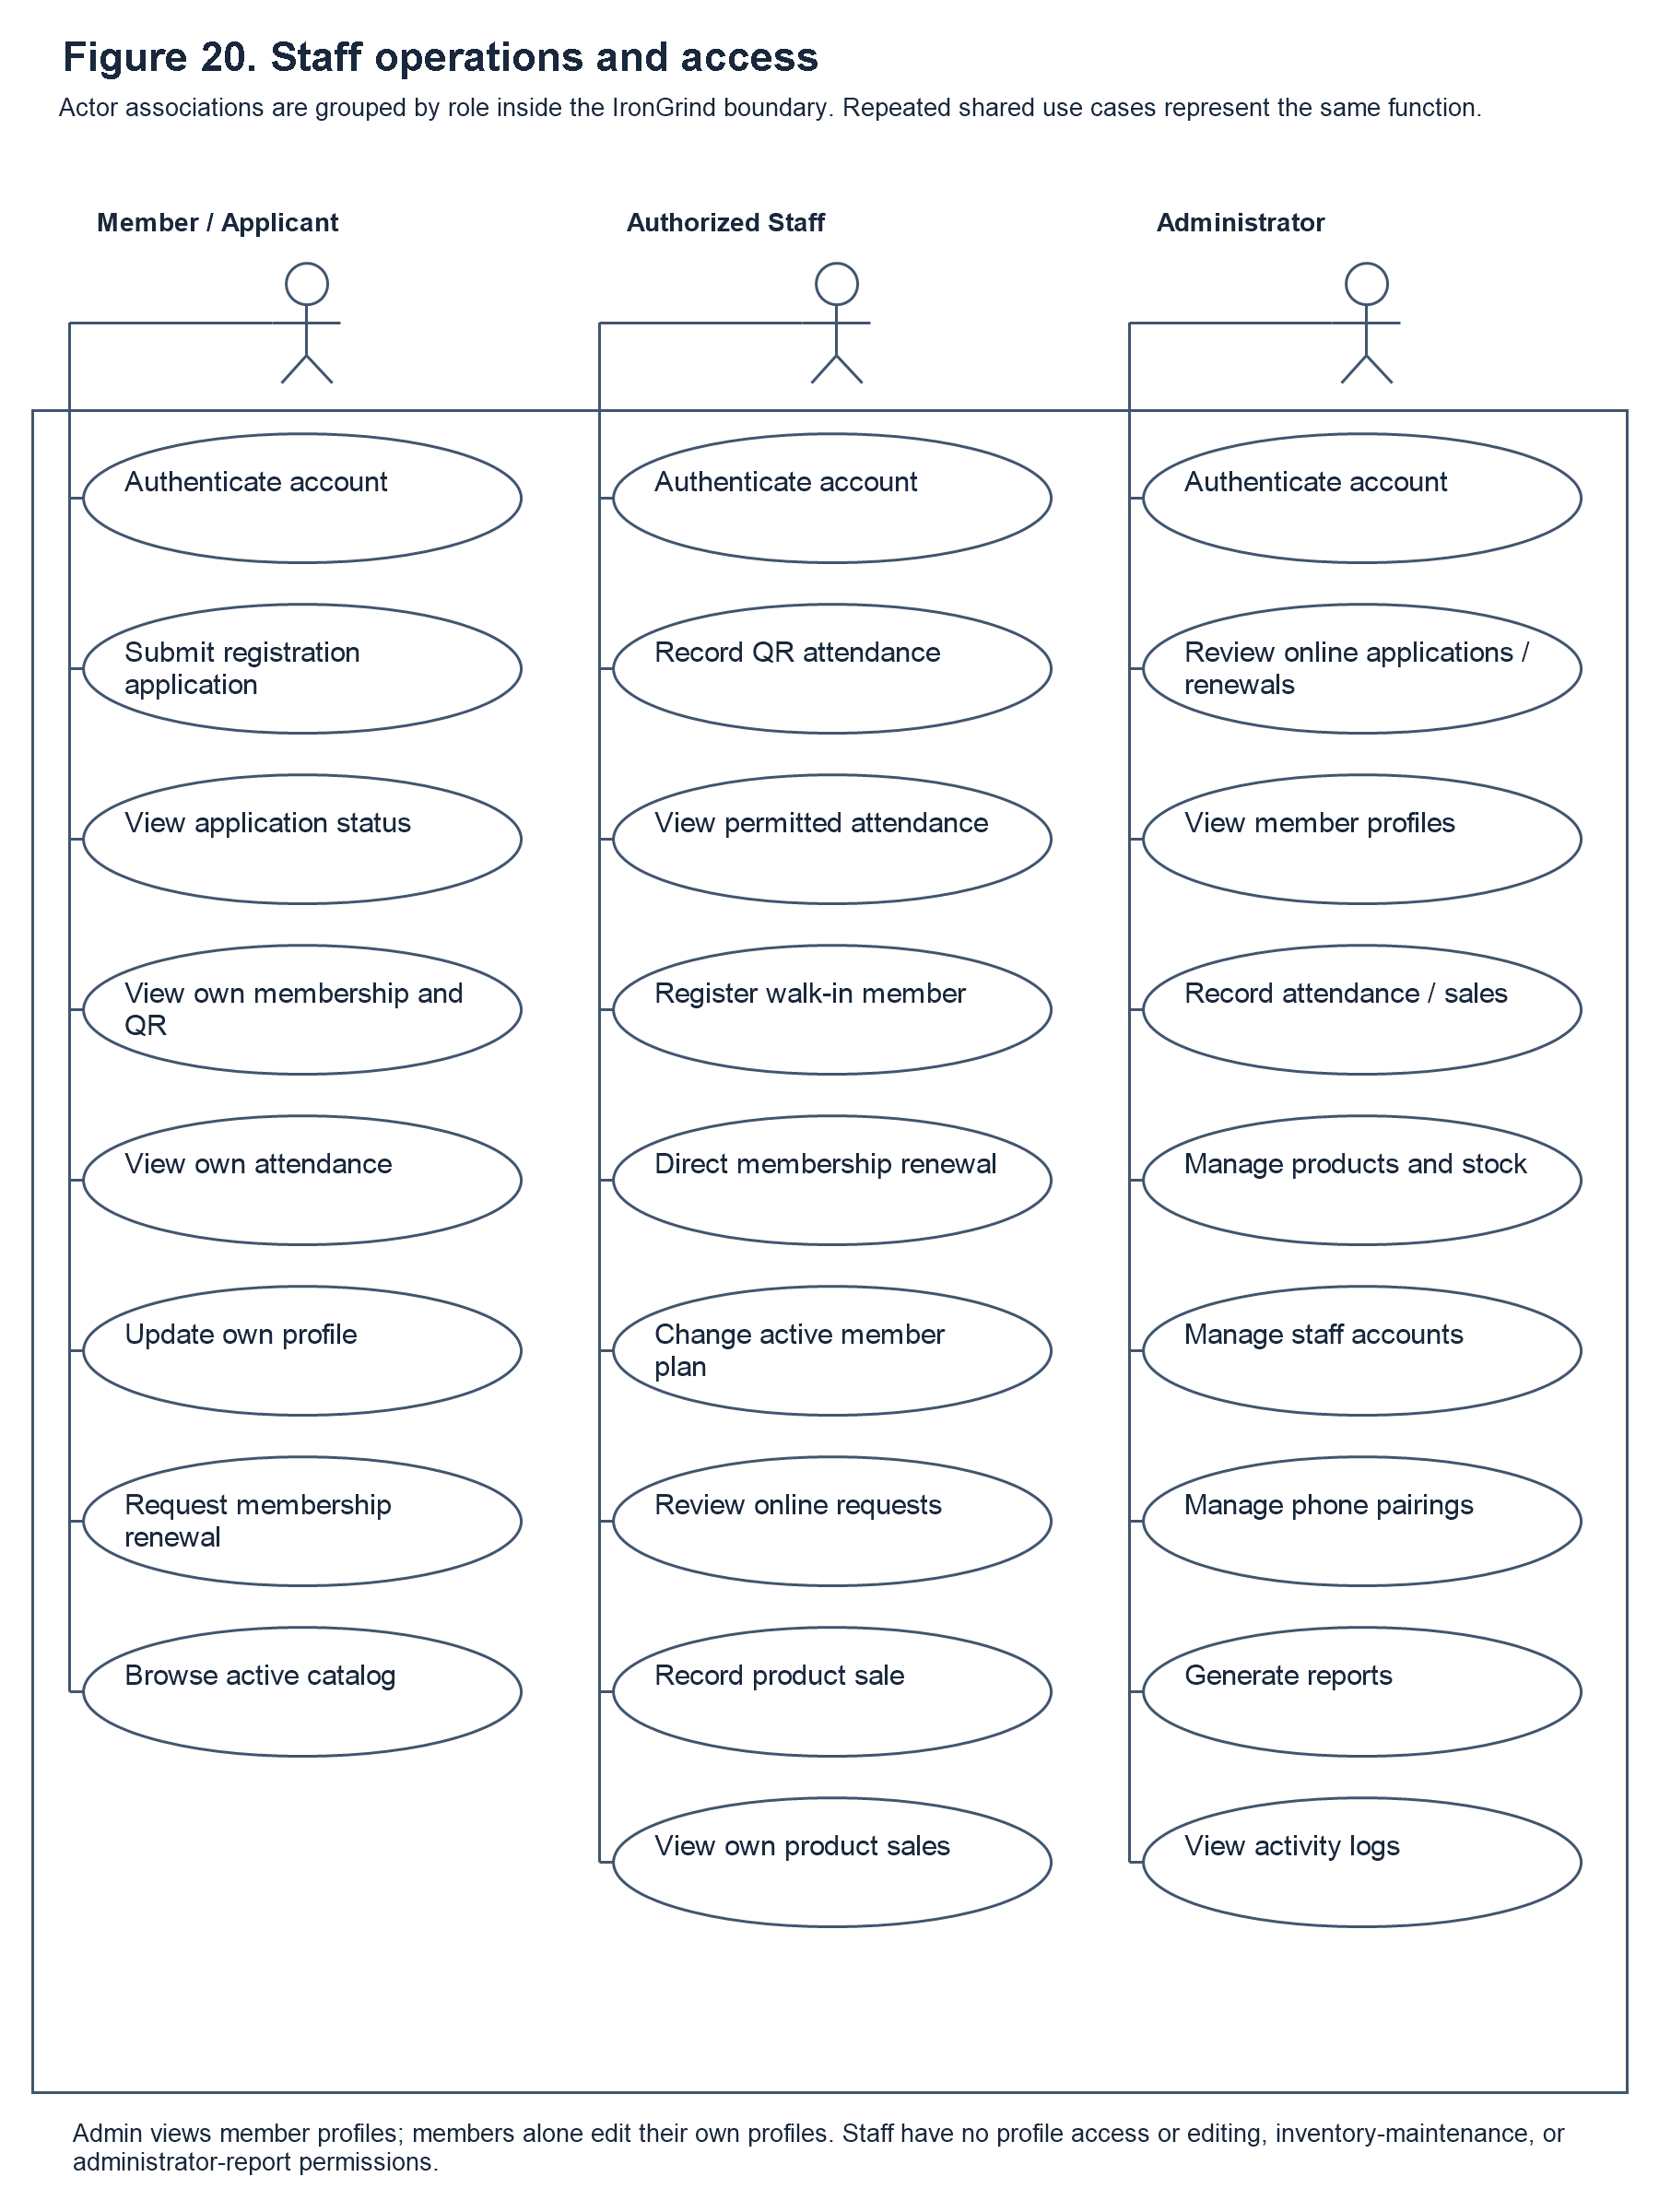
Figure 20. Staff operations and access
Staff Operations. Figure 20 summarizes staff attendance, counter registration, direct subscription renewal, active-member plan change, online registration and renewal request approval, product sales, and own-sales review, while distinguishing administrator-only controls. It is a workflow illustration rather than a captured interface. The earlier receipt illustration has been replaced to match the stated transaction-recording scope.

Gantt Chart

Figure 21. Gantt Chart
The Gantt chart presents the planned development schedule for the Iron Grind System over ten weeks, from August 24 to October 28. The work is organized into three phases. During Planning (Weeks 1–4), the team identifies a potential client, interviews the client, gathers feedback, and confirms the system requirements and proposed features. During Design (Weeks 5–8), the team creates and refines the user-interface design and prototypes using the requirements and feedback gathered during planning. During Development (Weeks 9–10), the team begins implementing the frontend, backend, database, API, and supporting components while continuing work on the project chapters. The phases show how the project moves from understanding the gym’s needs to designing and developing the system.
The horizontal timeline indicates when each planned activity was assigned, while the colored marks associate the activity rows with the corresponding week. The chart should be read as a schedule of intended work rather than as proof that an activity was completed on that date. Its planning, design, and development groups organize the original sequence of work; they do not replace the iterative refinement described in the Agile methodology. Since the system has subsequently changed, the chartâ€™s dates are retained as the original plan and should be distinguished from any separately verified record of actual development or deployment.

